TOTAL INVOICE
INTERNATIONAL TEAMGYM CUP 2015
KINGERSHEIM – France
October 23rd - 25th 2015

CLUB : …………………………………………..
NATION : …………………………………………..

COMPETITION :
…… x TEAM (130€) = …… €
…… x TRIO (65€) = …… €
…… x SOLO (3€) = …… €
TOTAL COMPETITION = …… €

JUDGE :
⃝ YES (0€)
⃝ NO (40€)

ACCOMODATION :
⃝ NO (0€)
⃝ YOUTH HOTEL (25€/NIGHT/PERSON) …… (Night) x …... (Person) x 25€ = ………. €
⃝ HOTEL (28€/NIGHT/PERSON) …… (Night) x …... (Person) x 28€ = ………. €

FOOD :
⃝ NO (0€)
⃝ FRIDAY LUNCH (8€/PERSON) …… (Meal) x …… (Personn) x 8€ = ………. €
⃝ FRIDAY DINNER (8€/PERSON) …… (Meal) x …… (Personn) x 8€ = ………. €
⃝ SATURDAY LUNCH (6€/PERSON) …… (Meal) x …… (Personn) x 6€ = ………. €
⃝ SUNDAY LUNCH (6€/PERSON) …… (Meal) x …… (Personn) x 6€ = ………. €

ITC PARTY KING
⃝ NO (0€)
⃝ YES (12€/PERSON) …... (Person) x 12€ = ………. €

TOTAL (COMPETITION + JUDGE + ACCOMODATION + ITC PARTY KING) = ………. €

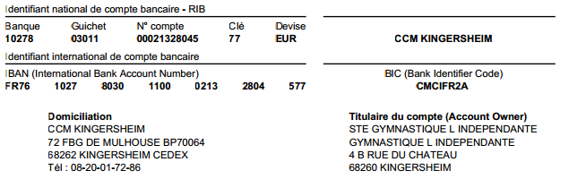

Gymnastic Hall, c/o Younesse El Hariri, 4 Gounod street, F - 68260 Kingersheim
Tel : +33 (0)6 32 67 63 28, E-Mail: luyufoo@hotmail.com

