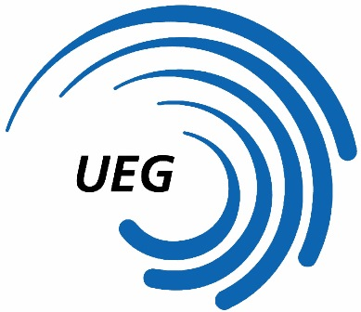
31st European WAG Championships
Bern (SUI)
June 1 - 5, 2016

Form to be sent to:
Organizing Committee / Host Federation
EM Kunstturnen Bern 2016
Ms. Lisa WORTHMANN
delegations@ec-bern2016.com

Deadline: May 2nd 2016
Music Release form

Federation |  | Contact person:
Federation |  | Phone:
Federation |  | E-mail:

LAST NAME, first name  of gymnast | Duration | Composer | Title | Artist

By signing in this form, the Federation confirms that the music used does not violate any copyrights
and that it can be broadcasted within sports.

Place and date | Seal of the NF | NF authorised signature
 |  | Signature of the President or Secretary General of the participating UEG affiliated NF

