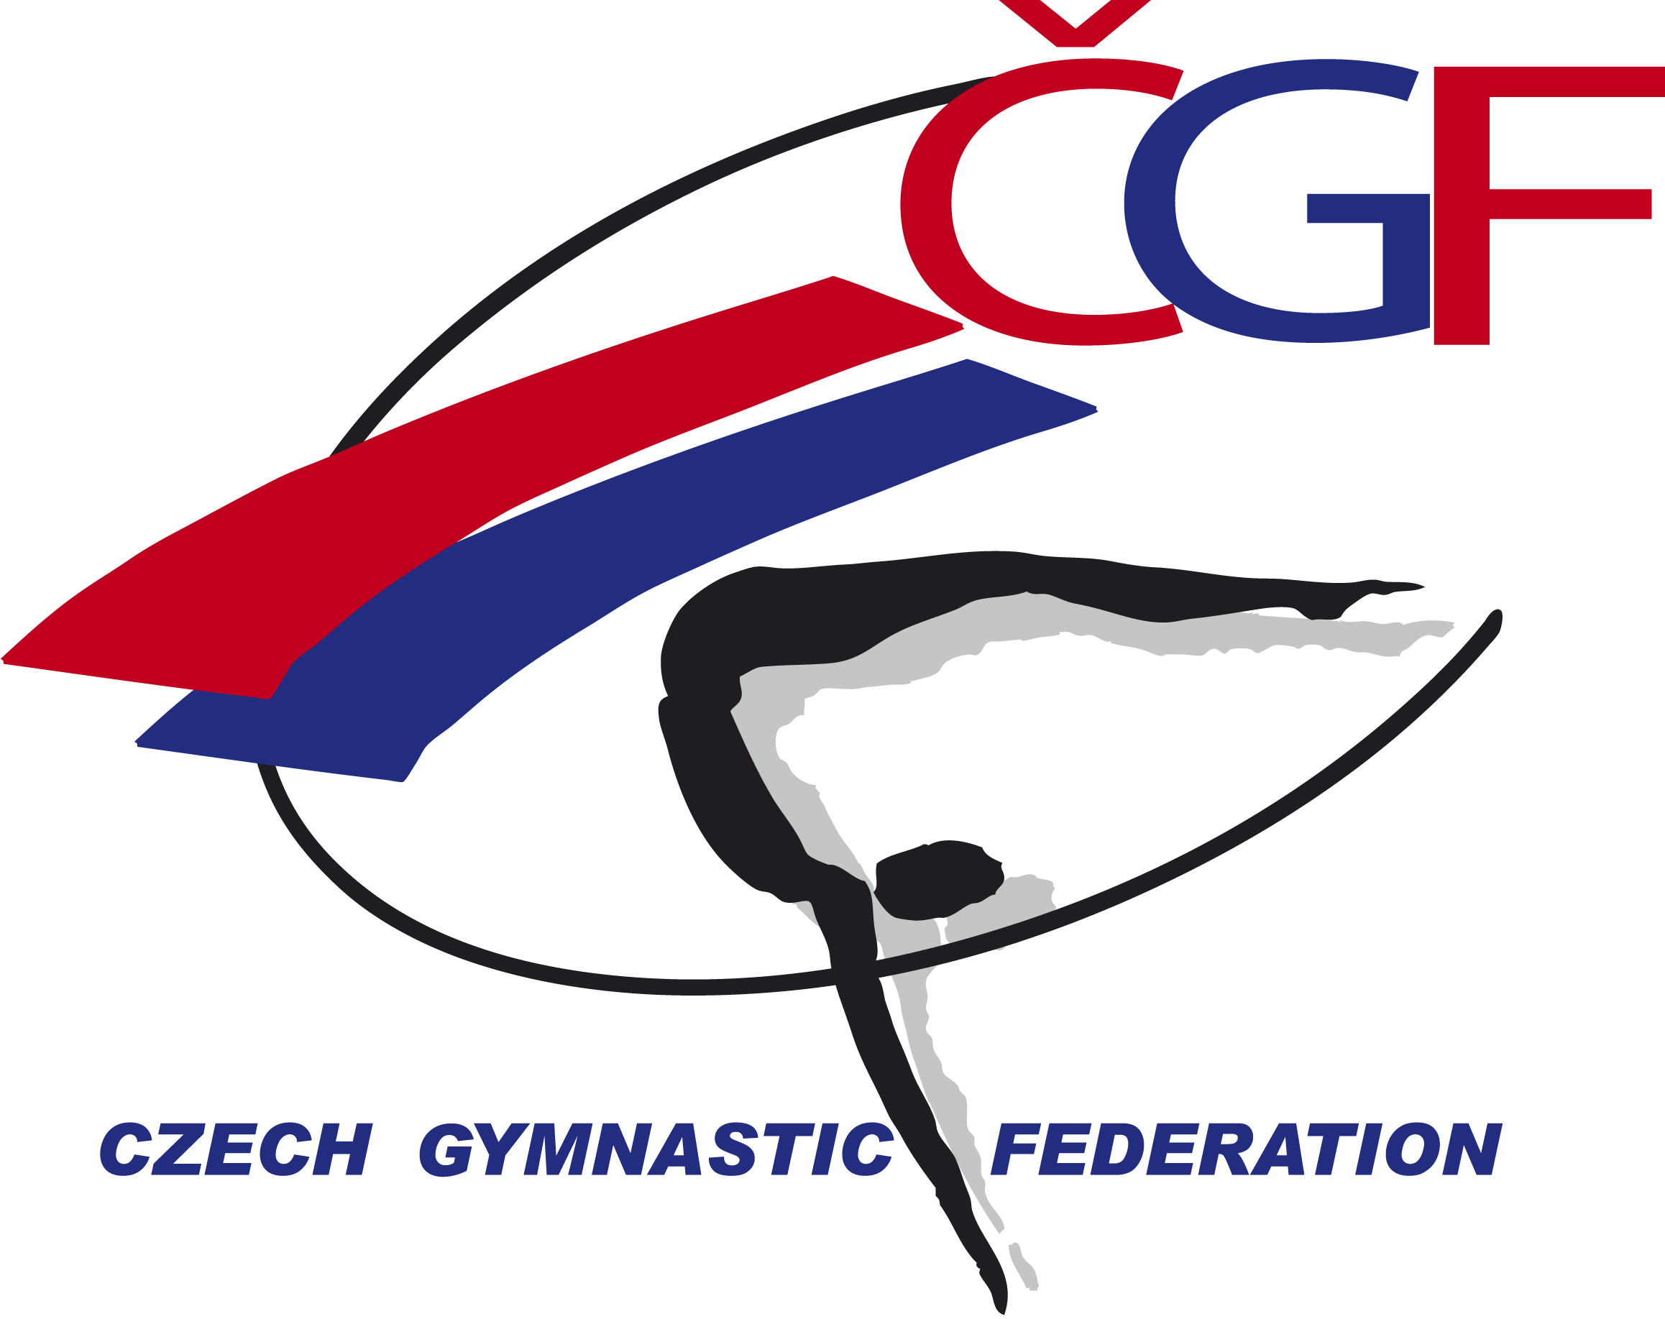

Olympic Hopes’ Cup – OHC Liberec 2016, (CZE, Liberec)

November 3rd – 6th, 2016
Form to be sent to:
Gymnastika Liberec / Czech Gymnastic Federation
Czech Gymnastics Federation
Zatopkova 100/2, P.O. Box 40, 16017 Praha 6
Phone: +420 242 429 260
e-mail: cgf@gymfed.cz
contact person: Zuzana Vojackova, 602 681 521
Deadline: October 21st 2016
ACCOMMODATION Form

Federation |  | Contact person:
Federation |  | Phone:
Federation |  | E-mail:

Package / Hotel name | Room type  (i.e. single/double/triple/quadruple) | Arr. day | Dept. day | LAST NAME,  First Name | Function | Price per  person per night | # of nights | Total
 |  |  |  |  |  | GRAND TOTAL

Special requirements

Place and date | Seal of the NF | NF authorised signature
 |  | Signature of the President or Secretary General of the participating FIG affiliated NF

