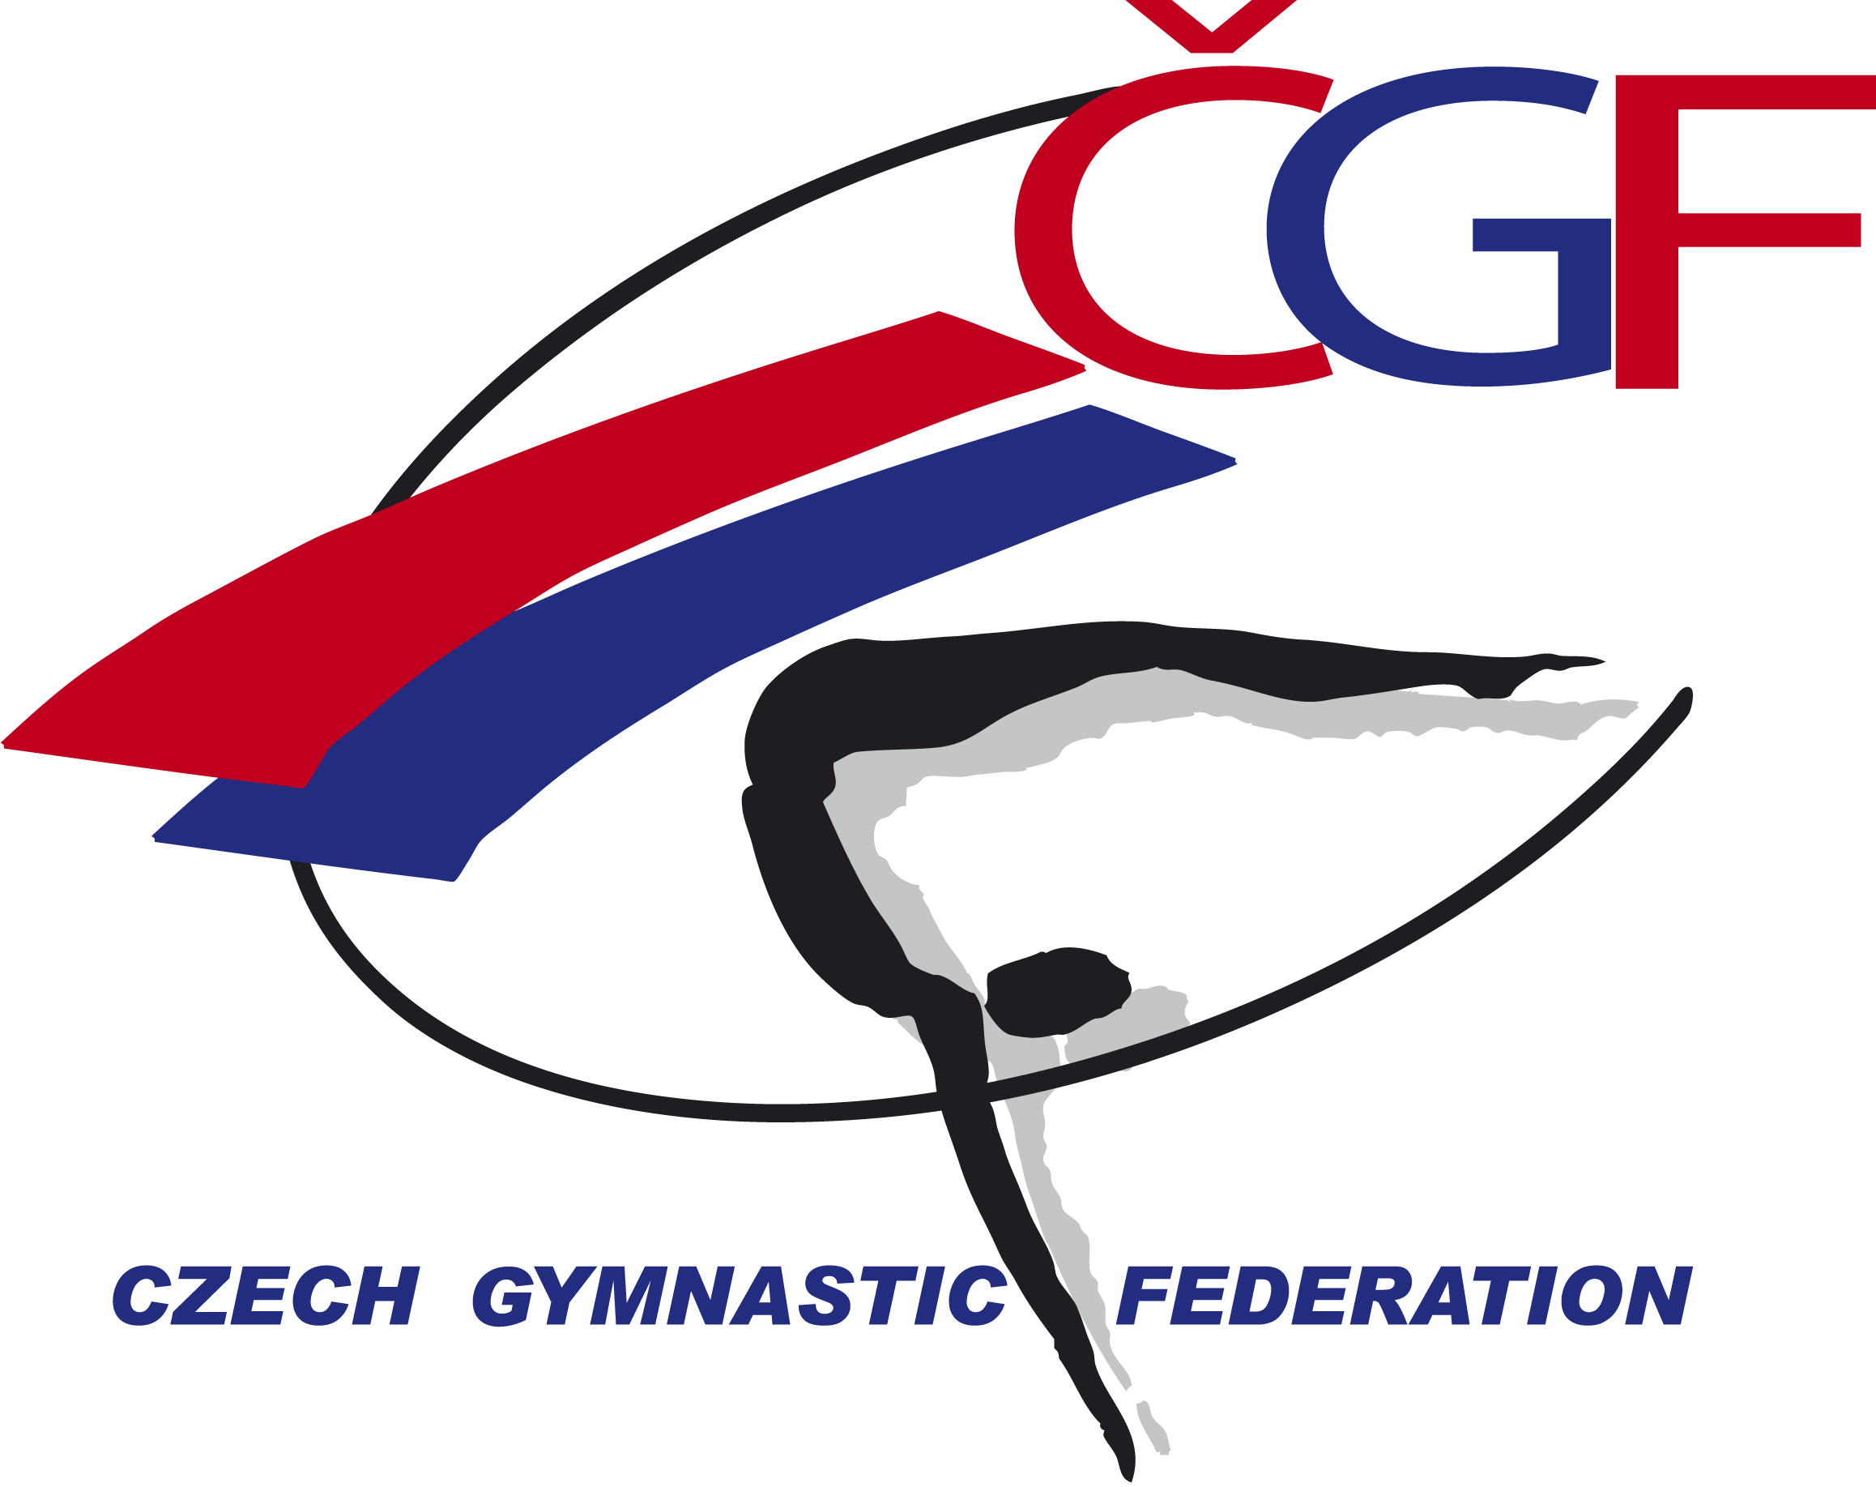

Olympic Hopes’ Cup –
OHC Liberec 2016
(CZE, Liberec)
November 3rd – 6th, 2016

Form to be sent to:
Gymnastika Liberec / Czech Gymnastic Federation
Czech Gymnastics Federation
Zatopkova 100/2, P.O. Box 40, 16017 Praha 6
Phone: +420 242 429 260
e-mail: cgf@gymfed.cz
http://www.gymfed.cz
contact person: Zuzana Vojackova, +420 602 681 521
Deadline: 10th OCTOBER 2016

DEFINITIVE REGISTRATION

Federation
Contact Person | Last name: |  | First name:
Address | Street: |  | Post Office Box:
Address | ZIP/Postcode: | Place: |  | Country:
Telephone / Fax | Telephone: | Mobile: |  | Fax:
E-mail

WE WILL PARTICIPATE YES NO

MALE GYMNASTS YES NO NUMBER

FEMALE GYMNASTS YES NO NUMBER

MAG COACHES YES NO NUMBER

WAG COACHES YES NO NUMBER

MAG JUDGES YES NO NUMBER

WAG JUDGES YES NO NUMBER

Place and date | Seal of the NF | NF authorised signature
…………………………………………….. |  | ……………………………………………..  Signature of the President or Secretary General of the FIG affiliated NF.

