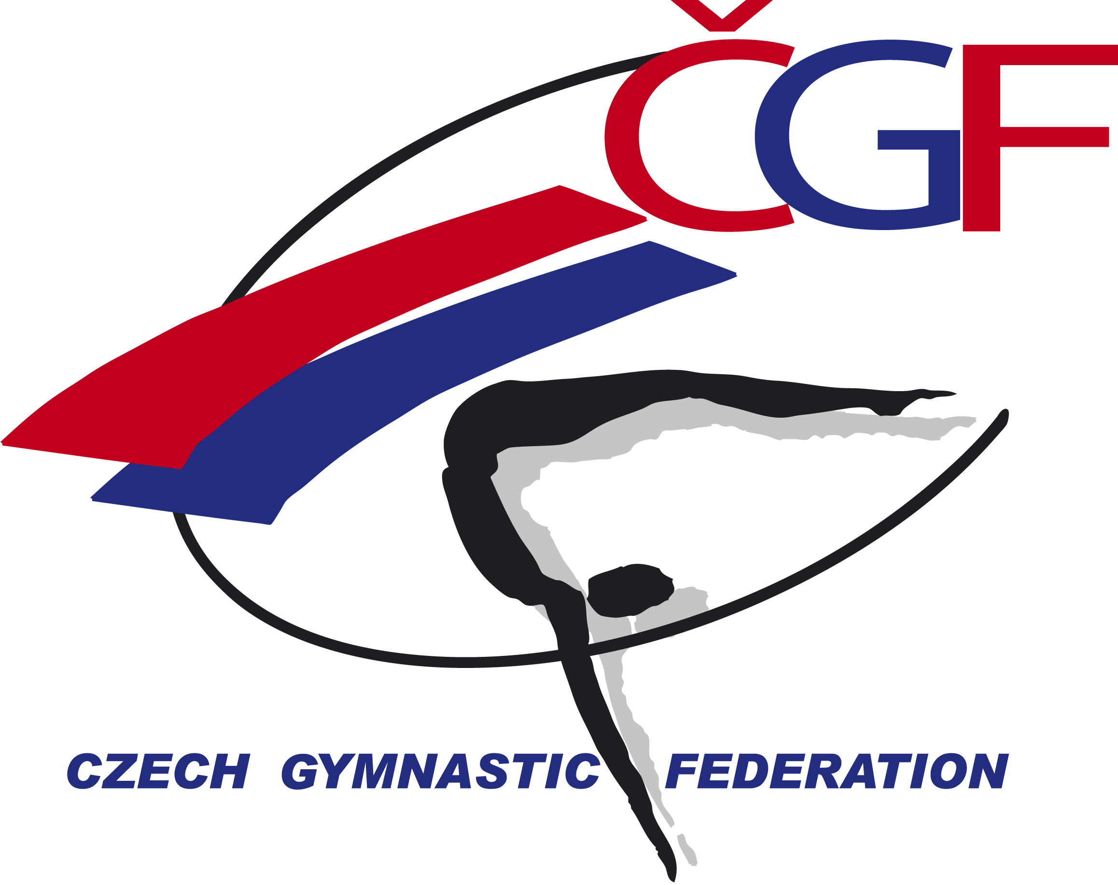

Olympic Hopes’ Cup –
OHC Liberec 2016
(CZE, Liberec)
November 3rd – 6th, 2016

Form to be sent to:
Gymnastika Liberec / Czech Gymnastic Federation
Czech Gymnastics Federation
Zatopkova 100/2, P.O. Box 40, 16017 Praha 6
Phone: +420 242 429 260
e-mail: cgf@gymfed.cz
contact person: Zuzana Vojackova, 602 681 521
Deadline: October 21st 2016
Travel Schedule Form

Federation |  | Contact person:
Federation |  | Phone:
Federation |  | E-mail:
If the team delegation is scheduled on more than one transportation mean, please complete one (1) form for
each transportation mean. For earlier arrival or later departure please contact the OC.
Arrival information
# of persons |  |  | # of luggage
Date: |  |  |  |  | Arrival time
By airplane | Airport: |  |  | Flight # |  | From
By train | Station: |  |  | Train # |  | From
By bus (complete if needed) | Station: |  |  | Bus # |  | From
By car

Departure information
# of persons |  |  | # of luggage
Date: |  |  |  |  | Departure time
By airplane | Airport: |  |  | Flight # |  | To
By train | Station: |  |  | Train # |  | To
By bus (complete if needed) | Station: |  |  | Bus # |  | To
By car

Transport from Prague Airport to Liberec and back - 50 €/ person. | Number |  | Total

Place and date | Seal of the NF | NF authorised signature
 |  | Signature of the President or Secretary General of the participating FIG affiliated NF

