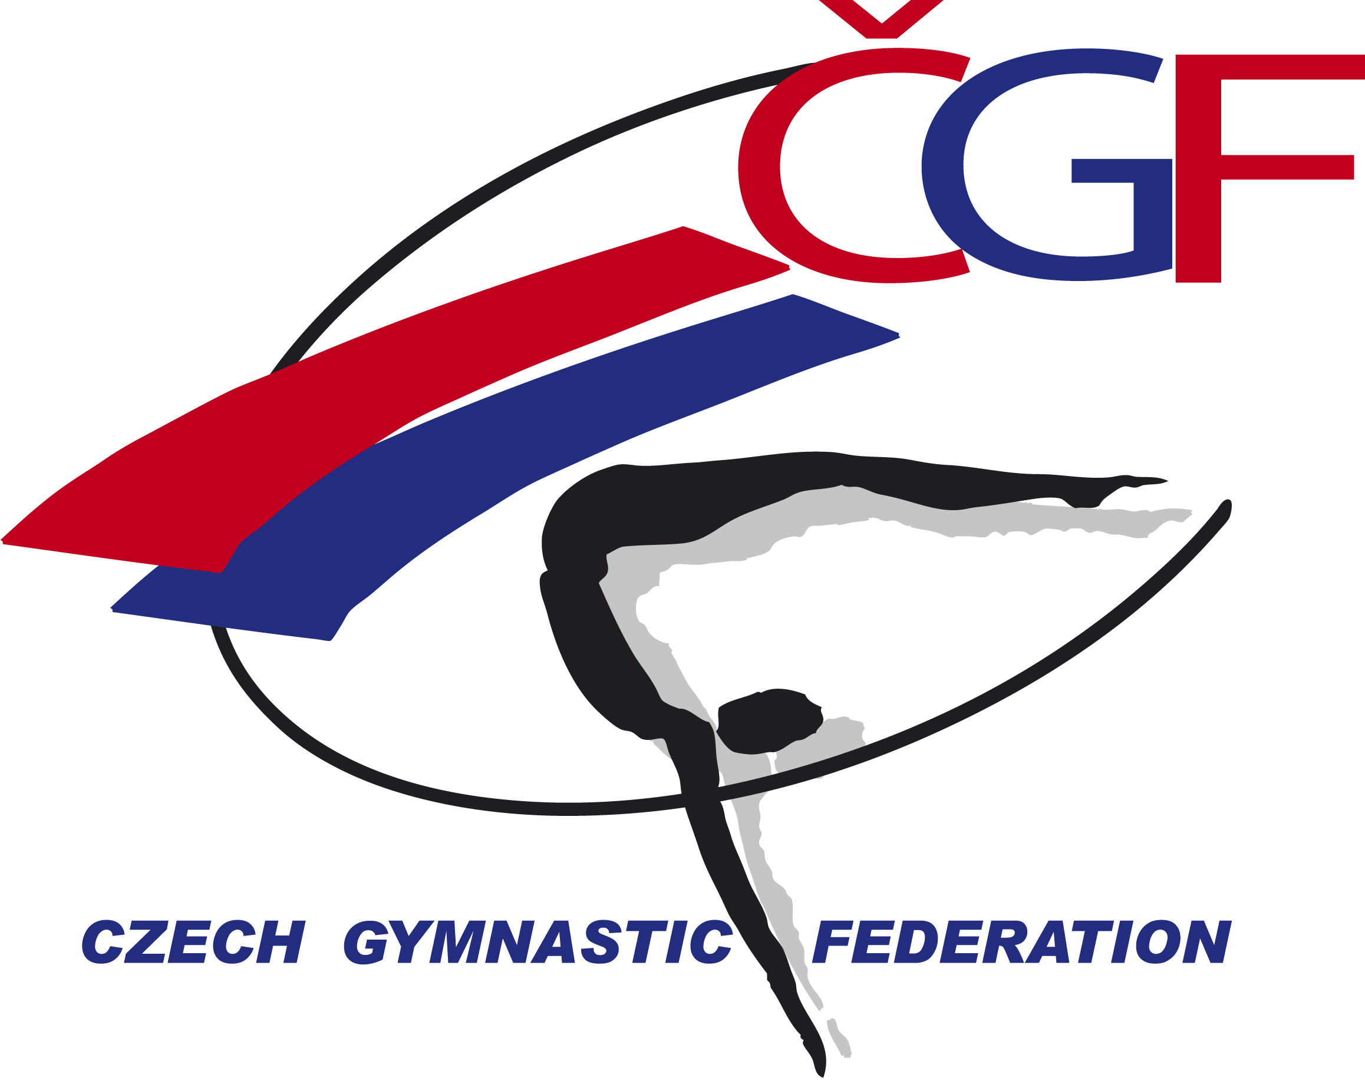

Olympic Hopes’ Cup – OHC Liberec 2016, (CZE, Liberec)
November 3rd – 6th, 2016

FIG Event ID
Form to be sent to:


Organizing Committee/Host Federation
Czech Gymnastics Federation
Zatopkova 100/2, P.O. Box 40, 16017 Praha 6
Phone: +420 242 429 260
e-mail: cgf@gymfed.cz
http://www.gymfed.cz
contact person: Zuzana Vojackova, +420 602 681 521

Deadline: 21st OCTOBER 2016

nominative entry – MAG

Federation
Contact Person
Address
Telephone / Fax
E-mail

FUNCTION | NAME & FIRST NAME | DATE OF BIRTH
GYMNAST 1
GYMNAST 2
GYMNAST 3
GYMNAST 4
GYMNAST 5
GYMNAST 6
COACH 1
COACH 2
JUDGE 1
JUDGE 2
GYMNAST RESERVE
DRIVER
HEAD OF DELEGATION
TOTAL MEMBERS OF DELEGATION

Place and date | Seal of the NF | NF authorised signature
 |  | Signature of the President or Secretary General of the FIG affiliated NF.

