
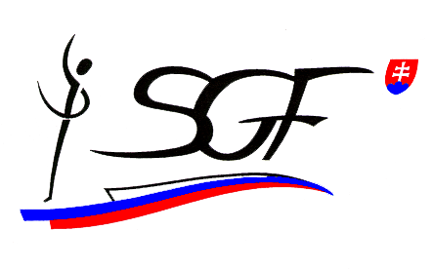

17th Slovak Aerobic Open
Nové Zámky – ŠURANY (SVK)
9th – 10th April 2016

FIG ID 14728

Dear FIG affiliated Member Federation,

The Slovak Gymnastics Federation has the honour to welcome 14 countries from 3 continents to participate in the aforementioned official FIG International Event - 17th Slovak Aerobic Open.

Participating countries:
ALGERIA, AUSTRIA, BELORUSSIA, BULGARIA, THE CZECH REPUBLIC, ESTONIA, GERMANY, HUNGARY, IRAN, LATVIA, LITHUANIA, MONGOLIA, ROUMANIA, AND SLOVAKIA.

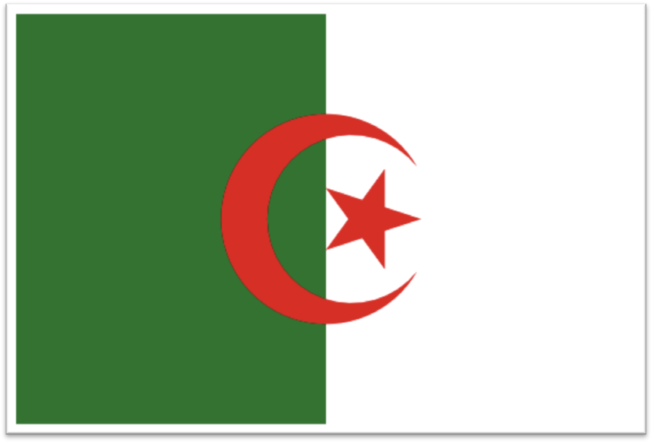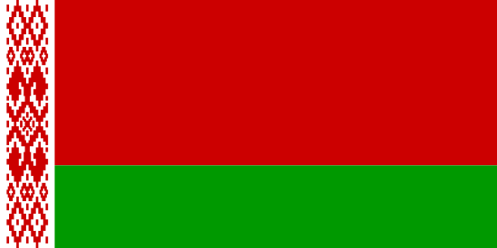

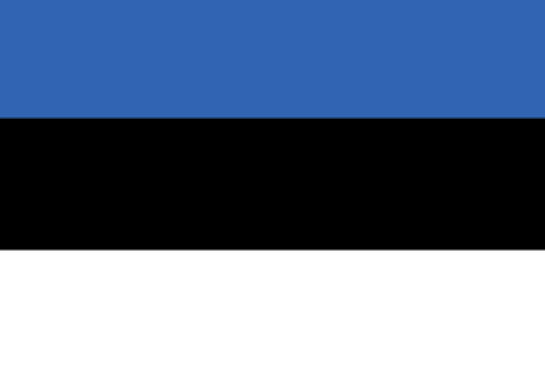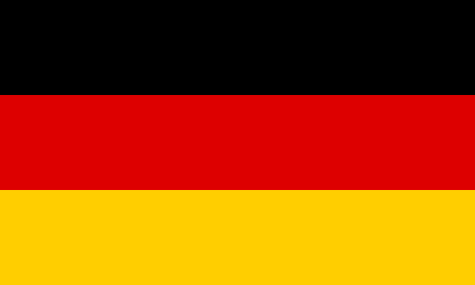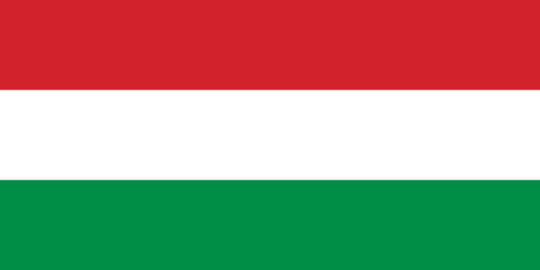

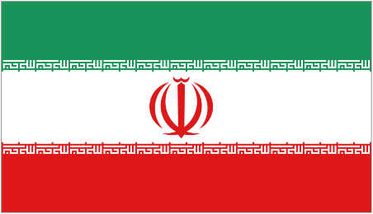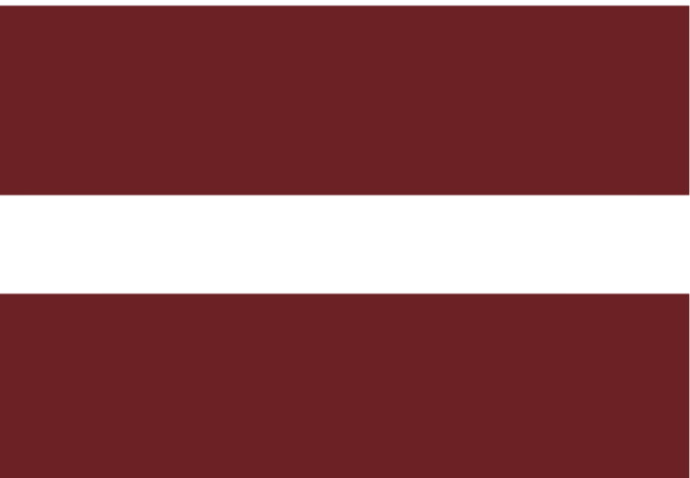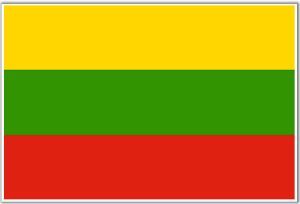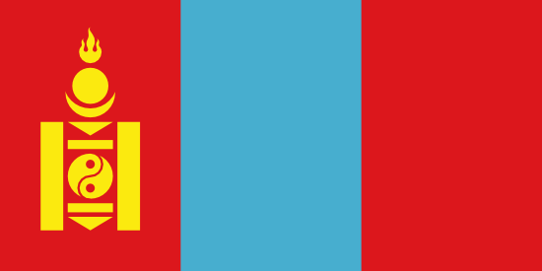

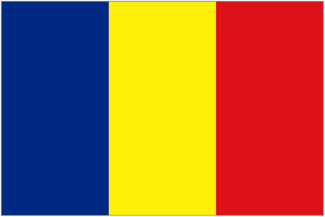

Competition venue

CITY SPORT HALL ŠURANY
Bernolákova 35
942 01 ŠURANY
SLOVAKIA

1. ACCREDITATION
The accreditation will take place at the CITY SPORTS HALL ŠURANY upon arrival to ŠURANY, (City Sports Hall) Friday, 8th April, 2016 from 16:00 to 18:30. Please, respect the time. The accreditations will only be handed out to the Head of Delegation. All delegations must deliver 1 music CD’s for each routine (do not forget to bring 1 additional CD for the training), difficulty elements list for each routine (or send by e-mail), insurance declaration, passports of all members.

2. schedule

Thursday, 7th April 2016
All Day | Arrival of the delegations | City Sports Hall ŠURANY

Friday, 8th April 2016
09.30 - 20.50 | Podium training | City Sports Hall ŠURANY
16.00 - 18.30 | Accreditation | City Sports Hall ŠURANY
18.30 | Orientation meeting | City Sports Hall ŠURANY
19.00 | Judges meeting and judges draw | City Sports Hall ŠURANY

Saturday, 9th April 2016
08.15 | Judges briefing | City Sports Hall ŠURANY
08.50  09.00 - 16.00 | Opening Ceremony & Presentation of the Nations  Qualification AG1 /AG2 /Sen | City Sports Hall ŠURANY
16.30 - 20.15 | Finals and Medal Award Ceremony  National Development | City Sports Hall ŠURANY
21.00 | Banquet (Head of Delegations, coaches, judges) | Restaurant & pizzeria “ÁČKO”

Sunday, 10th April 2016
08.00 - 10.00 | Podium training - optional | City Sports Hall ŠURANY
09.30 | Judges briefing and judges draw | City Sports Hall ŠURANY
10.25  10.30 - 12.30 | Presentation of the Nations  Finals AG 1/ AER DANCE & AER STEP  Medal Award Ceremony | City Sports Hall ŠURANY
14.00 - 17.00 | Finals AG 2 / SENIORS  Medal Award Ceremony | City Sports Hall ŠURANY
 | Optional departure

Monday, 11th April 2016
All day | Departure of the delegations | Hotels

3. Categories
National Development 8 - 11 years
Age Group 1 12 - 14 years
Age Group 2 15 - 17 years
Seniors 18 years and older

4. Qualifications
The maximum number for the Qualifying rounds is four (4) per category and nation (upon a request 6 max). There will be no qualification if 10 (less) competitors (routines) in categories (IW, IM, MP, TR, GR).

5. Finals
- National Development:
Only the finals (IW, IM, MP, TR, GR)

- Age Group 1, Age Group 2 and Seniors:
Each final (IW, IM, MP, TR, GR): maximum of ten (10) competitors: 7 best foreign competitors (max. 2 per nation) + 3 Slovak competitors (maximum).

- Aerobic Dance and Aerobic Step:
Only the finals (AG1, AG2 and Seniors categories).

6. ORGANIZING COMMITTEE CONTACT
Slovak Gymnastics Federation, Junácka 6, 832 80 Bratislava, Slovakia
Phone: +421 2 492 491 49
Fax: +421 2 492 49 538
e-mail: gymnastics@sgf.sk

7. ACCOMMODATION
KORZO Hotel***  F. Rákocziho 12  940 56 Nové Zámky  Tel. +421 (0)35 6400430  Fax: +421(0)35 6400431  e-mail: recepcia@hotelkorzonz.sk  www.hotelkorzonz.sk | SALUR Hotel**  Komárňanská cesta 3  940 56 Nové Zámky  Tel. +421 911 233 500  e-mail: salur@salur.sk  www.salur.sk
Penzion Quatro I-IV***  Termálna  941 48 Podhájska  Tel. +421 907 884 866  www.apartmanypodhajska.info | Penzion Lagáň***  Radava 471  940 01Radava  Tel. + 421 035/650 76 50  www.penzionlagan.sk

If any other questions concerning competition do not hesitate to contact us.

Monika Šišková
General Secretary SGF gymnastics@sgf.sk
+421 905 811 053

Oľga KYSELOVIČOVÁ Martin MUCHA
SGF AG -TC President LOC President
kyselovicova@fsport.uniba.sk +421 903 958 042
+421 903 227 582

PODIUM TRAINING

Friday, 08.04.2016

FRIDAY, 08. 04. 2016 |  | Delegation (number of routines) | Podium
FRIDAY, 08. 04. 2016 | 1 | SVK / GK N.Zámky + Fanatik Bánov + KGŠ Trnava (18) | 9:30 – 10:06
FRIDAY, 08. 04. 2016 | 2 | SVK / KŠA Nitra (26) | 10:06 – 10:58
FRIDAY, 08. 04. 2016 | 3 | ALG + GER + MGL (3+4+4) | 10:58 – 11:20
FRIDAY, 08. 04. 2016 | 4 | SVK / Inter Bratislava (10) | 11:20 – 11:40
FRIDAY, 08. 04. 2016 | 5 | ROU (13) | 11:40 – 12:06
FRIDAY, 08. 04. 2016 | 6 | SVK / VŠK FTVŠ UK Lafranconi Bratislava (12) | 12:06 – 12:30
FRIDAY, 08. 04. 2016 | 7 | BUL (32) | 12:30– 13:34
FRIDAY, 08. 04. 2016 | 8 | SVK / Slávia PU Prešov (20) | 13:34 – 14:14
FRIDAY, 08. 04. 2016 | 9 | LTU (37) | 14:14 – 15:28
FRIDAY, 08. 04. 2016 | 10 | CZE (47) | 15:28 – 17:00
FRIDAY, 08. 04. 2016 | 11 | EST + LAT (14+9) | 17:00 – 17:46
FRIDAY, 08. 04. 2016 | 12 | AUT + BLR + IRI (13+4+1) | 17:46 – 18:18
FRIDAY, 08. 04. 2016 | 13 | HUN (78) | 18:18 – 20:50

SATURDAY, 09.04.2016
optional Training only!!! NO scheduled!!! 7:30 – 8:30

SUNDAY, 10.04.2016

SUNDAY, 10.04. 2016 |  | Delegation | Podium
SUNDAY, 10.04. 2016 | 1 | SVK / GK Nové Zámky + Fanatik Bánov | 08.00 – 08.10
SUNDAY, 10.04. 2016 | 2 | SVK / Slávia PU Prešov | 08.10 – 08.20
SUNDAY, 10.04. 2016 | 3 | SVK / KŠA Nitra | 08.20 – 08.30
SUNDAY, 10.04. 2016 | 4 | SVK / KGŠ Trnava + VŠK FTVŠ UK Bratislava | 08.30 – 08.40
SUNDAY, 10.04. 2016 | 5 | LTU | 08.40 – 08.50
SUNDAY, 10.04. 2016 | 6 | LAT + BLR + ROU | 08.50 – 09.00
SUNDAY, 10.04. 2016 | 7 | BUL | 09.00 – 09.10
SUNDAY, 10.04. 2016 | 8 | ALG + AUT + IRI + MGL + GER | 09.10 – 09.20
SUNDAY, 10.04. 2016 | 9 | HUN | 09.20 – 09.30
SUNDAY, 10.04. 2016 | 10 | CZE | 09.30 – 09.40

