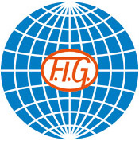

SOKOL GRAND PRIX DE GYMNASTIQUE
Brno, Czech Republic
26th November, 2016



Form to be sent to:
Organizing Committee
T.J. Sokol Brno I - Gymnastics Club
Contact person: Mr Martin Vlk
Tel.: +420 733 777 368, Email: vlkm@sokol.eu and sokolbrno1@gmail.com

Deadline: 25th SEPTEMBER, 2016

Definitive registration

Federation |  | Contact person:
Federation |  | Phone:
Federation |  | E-mail:

THE GYMNASTICS FEDERATION OF: ...................……………………………………..….

has intention to take part in the “SOKOL GRAND PRIX DE GYMNASTIQUE” with

1 MIXED PAIR (1 MAG gymnast + 1 WAG gymnast) YES NO

1 MAG GYMNAST only YES NO

1 WAG GYMNAST only YES NO

* if NF have only MAG or WAG gymnast, they will complete with gymnasts from another NF

Place and date | Seal of the NF | NF authorised signature
 |  | Signature of the President or Secretary General of the participating FIG affiliated NF

