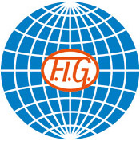

SOKOL GRAND PRIX DE GYMNASTIQUE
Brno, Czech Republic
26th November, 2016



Form to be sent to:
Organizing Committee
T.J. Sokol Brno I - Gymnastics Club
Contact person: Mr Martin Vlk
Tel.: +420 733 777 368, Email: vlkm@sokol.eu and sokolbrno1@gmail.com

Deadline: 25th OCTOBER, 2016

Nominative registration

Federation |  | Contact person:
Federation |  | Phone:
Federation |  | E-mail:

MAG GYMNASTS:
FAMILY NAME | GIVEN NAME | DATE OF BIRTH | FIG LICENCE Nr
WAG GYMNASTS:
FAMILY NAME | GIVEN NAME | DATE OF BIRTH | FIG LICENCE Nr
MAG COACHES:
FAMILY NAME | GIVEN NAME | DATE OF BIRTH
WAG COACHES:
FAMILY NAME | GIVEN NAME | DATE OF BIRTH

Place and date | Seal of the NF | NF authorised signature
 |  | Signature of the President or Secretary General of the participating FIG affiliated NF

