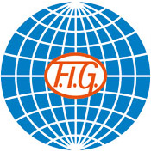


SOKOL GRAND PRIX DE GYMNASTIQUE
Brno, Czech Republic
26th November, 2016

Form to be sent to:
Host Federation
Czech Gymnastics Federation
Contact person: Mr Roman Slavik, Mrs Zuzana Vojackova
Tel.: +420 242 429 260, Email: cgf@gymfed.cz

Deadline: 25th OCTOBER, 2016
VISA REQUEST Form

Federation |  | Contact person:
Federation |  | Phone:
Federation |  | E-mail:

LAST NAME,  First name | Function | Gender  M/F | Date of birth  dd.mm.yyyy | Citizenship and  passport N° | Passport expiry date | Arrival date | Departure date | City*
* city where the visa application support letter must be sent to
Place and date | Seal of the NF | NF authorised signature
 |  | Signature of the President or Secretary General of the participating FIG affiliated NF

