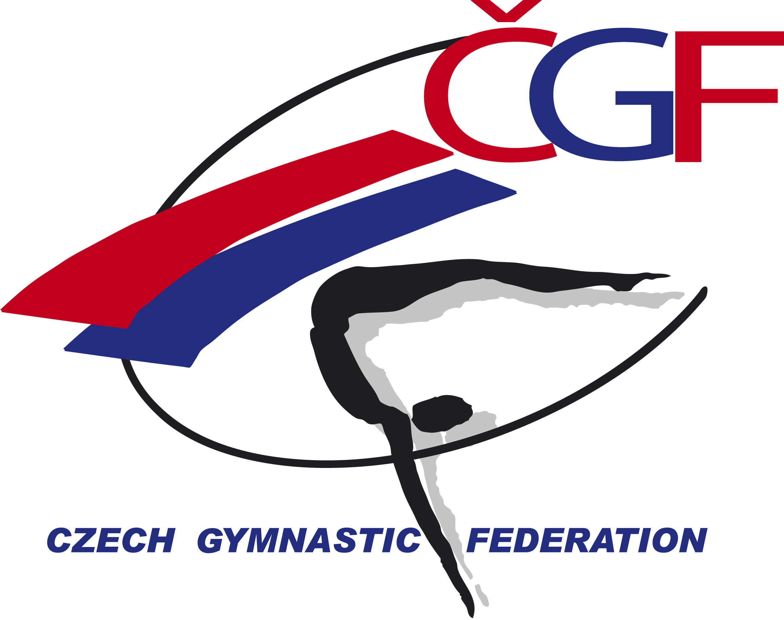

Sokol Grand Prix de Gymnastique Brno 2018
Brno, Czech Republic
24th November, 2018

Form to be sent to:
Tj Sokol Brno I / Czech Gymnastic Federation
Czech Gymnastics Federation
Zatopkova 100/2, P.O. Box 40, 16017 Praha 6
Phone: +420 242 429 260
e-mail: cgf@gymfed.cz
http://www.gymfed.cz
contact person: Zuzana Vojackova, +420 602 681 521
Deadline: 24th SEPTEMBER 2018

DEFINITIVE REGISTRATION

Federation
Contact Person | Last name: |  | First name:
Address | Street: |  | Post Office Box:
Address | ZIP/Postcode: | Place: |  | Country:
Telephone / Fax | Telephone: | Mobile: |  | Fax:
E-mail

WE WILL PARTICIPATE YES NO

GYMNAST PAIRS YES NO NUMBER

MAG COACHES YES NO NUMBER

WAG COACHES YES NO NUMBER

MAG JUDGES YES NO NUMBER

WAG JUDGES YES NO NUMBER

Place and date | Seal of the NF | NF authorised signature
…………………………………………….. |  | ……………………………………………..  Signature of the President or Secretary General of the FIG affiliated NF.

