

Sokol Grand Prix de Gymnastique Brno 2018
Brno, Czech Republic
24th November, 2018

DIRECTIVES

Event ID:
Dear FIG affiliated Member Federation,

The Czech Gymnastics Federation and Gymnastics Club T.J. Sokol Brno I has the pleasure to invite your Federation to participate in the aforementioned official FIG International Event.
Discipline | Mens Artistic Gymnastics & Womens Artistic Gymnastics
Host Federation | Czech Gymnastics Federation  Contact person: Mr Roman Slavík, Mrs Zuzana Vojáčková  Full address: Zátopkova 100/2, 160 17 Praha 6, Czech Republic  Phone number: +420 242 429 260  E-mail: cgf@gymfed.cz  Web site: http://www.gymfed.cz
OrganizING COMMITTEE | T.J. Sokol Brno I - Gymnastics Club  Contact person: Mr. Martin Vlk  Full address: Kounicova 20/ 22, 602 00 Brno, Czech Republic  Phone number: +420 541 212 805, 733 777 368  E-mail: mvlk@sokol.eu  Web site: http://gymnastika.sokolbrno1.cz
LOCATION | Brno, Czech Republic
DateS | November 23. – 25. 11. 2018
Venue | T.J. Sokol Brno I – Sports Hall  Full address: Kounicova 20/ 22, 602 00 Brno, CZE  Phone number: +420 541 212 805  GSM: 733 777 368  E-mail: mvlk@sokol.eu  Web site: http://gymnastika.sokolbrno1.cz
APPARATUS SUPPLIER | SPIETH, DIONY
RULES AND REGULATIONS | The competition will be organized according the following FIG rules, as valid in the year of the competition, except for any deviation mentioned in these directives:  Statutes  Technical Regulations  - Code of Points and relevant Newsletters  - General Judges’ Rules  - Specific Judges’ Rules  - Doping Control Rules  - Licence rules (except for non competitive events)  - Media Rules  - Apparatus Norms  - FIG Rules for Sanctioning (approval) of International Events  - Advertising and Publicity Rules  and subsequent decisions of the FIG Executive Committee
federations invited | The Organizing Committee invites all FIG Member Federations.
AGE LIMITS | WAG - Senior Category: 16 years and older  MAG – Senior Category: 18 years and older  All gymnasts must have a valid FIG licence until the end of the event.
REGISTRATION DEADLINES
  Definitive registration: | September 24th, 2018
  Nominative registration: | October 24th, 2018
ENTRY FEES | No Entry Fee will be applied for this event.
ACCREDITATION | All members will receive the accreditation card after arrival.
Competition Format | The competition proceeds in 3 rounds:  The first round - qualification: 10 couples take part, every gymnast performs on two pieces of apparatus.  The second round – semi-finals: 6 best-ranked couples pass to the second round. In case of a tie for 6th place, all the couples for 6th place will participate in the second round. The starting order of the couples will be according to the results of the first round: the couple on the 6th place shall start. In the semi-finals the gymnasts perform on one piece of apparatus which must be different from first round. The results of the first round are not carried forward to the second round - start from zero.  The third round - finals: 4 best ranked couples in the semi-finals pass to this final round. In case of a tie for 4th place the couple with the better result in the qualification round will participate in the 3rd round. If there is also a tie, the couple with the higher number of highest scores will participate in the 3rd round. The starting order will be determined by drawing of lots. In the final the female and male gymnasts perform on any of the pieces of apparatus (they can repeat any of already used piece except apparatus from the second round). The results of the previous rounds are not carried forward to the 3rd round - start from zero. The Grand Prix winner is the couple with the highest sum of scores in the third round.
PROVISIONAL Schedule | Friday November 23th, 2018: arrival of delegations and training  Saturday November 24th, 2018: training, 16:30 competition  Sunday November 25th, 2018: departure of delegations
MEDICAL SERVICES | MUDr. Luboš Hrazdíra
VISA | Please verify immediately with your travel agent or the Embassy or Consulate in your country if a visa is required for your travel to Czech Republic. The Organizing Committee (OC) will be happy to assist each Delegation member with an official invitation letter, provided that the request is made before September 24th, 2018 to the OC.  The request must include the function, full name, gender, date of birth, citizenship and passport number, passport expiry date, the arrival and departure dates of the Delegation Member as well as the city the visa application support letter must be sent to.
INSURANCE | The Host Federation, the Organizing Committee and the FIG will not be held responsible for any liabilities in case of accidents, illness, repatriation and the like.  The FIG Technical Regulations foresee that all participating Federations are responsible for making their own arrangements to have the necessary valid insurance coverage against illness, accidents and for repatriation for all the members of their Delegation.  The LOC will verify the insurance upon arrival of the delegation members (e.g. cover note or photocopy of the valid policy). Delegation members with insufficient insurance cover must inform the LOC in advance.
INternational TRANSPORTATION | The invited participating federations must pay for the travel costs of their delegation members (see exception herein below).  The Travel Schedule Form must be returned to the OC  by October 24th, 2018
LOCAL TRANSPORTATION | Organiser will provide transportation from/to the airport or railway station or bus station to/from the hotel.
ACCOMMODATION | HOTEL CONTINENTAL****  Full address: Kounicova 680/6, 602 00 Brno, CZ  Phone number: +420 541 519 111  E-mail: info@continentalbrno.cz  Web site: www.continentalbrno.cz  Organizing Committee will cover all costs for accommodation.
MEALS | Organizing Committee will cover all costs for meals (breakfast, lunch, dinner).
FINAL BANQUET | Final Banquet is intended for all members of competition (competitors, coaches, judges) and will be free of charge for them.
JUDGES AND JURIES | All judges must have a current valid FIG brevet at the time of the event.  For WAG and MAG will be only 1 panel of judges (2D+4E).
PRIZE MONEY | The Prize Money, free of any deductible taxes, will be distributed in euros as follows:
  Prize Money in euros
  Ranking
  1 | 1200€ for pairs
  2 | 800€ for pairs
  3 | 600€ for pairs
Marketing | FIG advertising and publicity norms must be respected.
ADDITIONAL INFORMATION | Starting money:  Every medailist of OG 2016, WCH 2017 or ECH 2016/2018, will receive the starting money at the amount of 300 EUR.  Every finalist of OG 2016, WCH 2017 or ECH 2016/2018 will receive the starting money at the amount of 200 EUR.  Only one of above amounts is valid for one attendee.  The female gymnasts will bring their music for floor on USB flash disk.
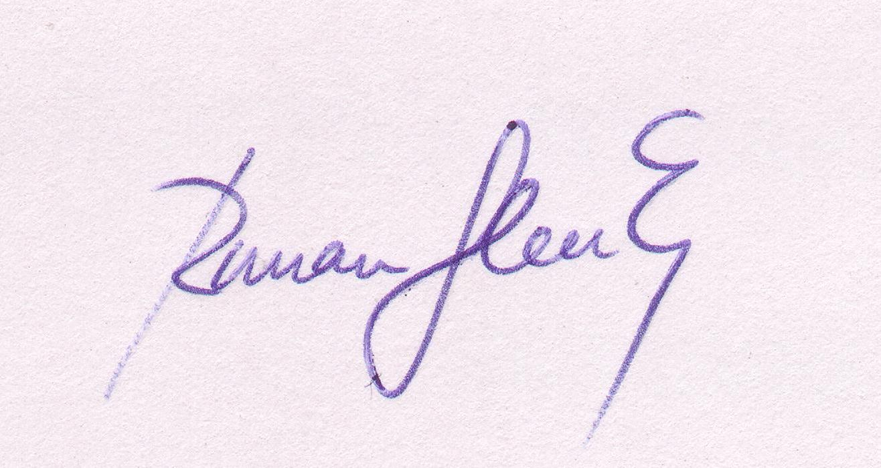
Sincerely Yours,
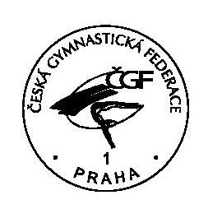
BRNO
Place and date: Stamp Signature of the President
of the FIG affiliated NF

