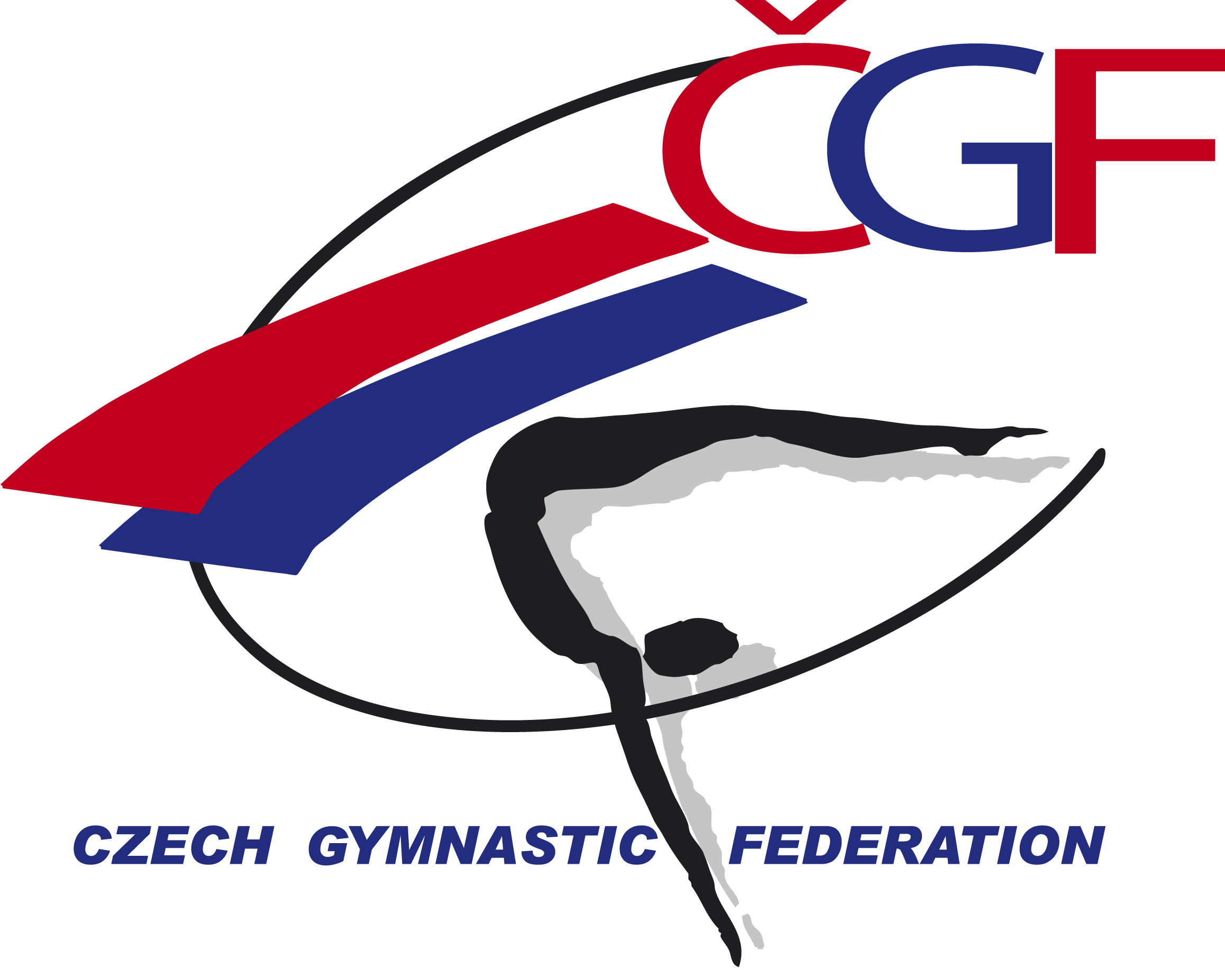

Sokol Grand Prix de Gymnastique Brno 2018
Brno, Czech Republic
24th September, 2018

Form to be sent to:
TJ Sokol Brno I / Czech Gymnastic Federation
Czech Gymnastics Federation
Zatopkova 100/2, P.O. Box 40, 16017 Praha 6
Phone: +420 242 429 260
e-mail: cgf@gymfed.cz
contact person: Zuzana Vojackova, 602 681 521
Deadline: September 24th, 2018
VISA REQUEST Form

Federation |  | Contact person:
Federation |  | Phone:
Federation |  | E-mail:

LAST NAME,  First name | Function | Gender  M/F | Date of birth  dd.mm.yyyy | Citizenship and  passport N° | Passport expiry date | Arrival date | Departure date | City*
* city where the visa application support letter must be sent to
Place and date | Seal of the NF | NF authorised signature
 |  | Signature of the President or Secretary General of the participating FIG affiliated NF

