
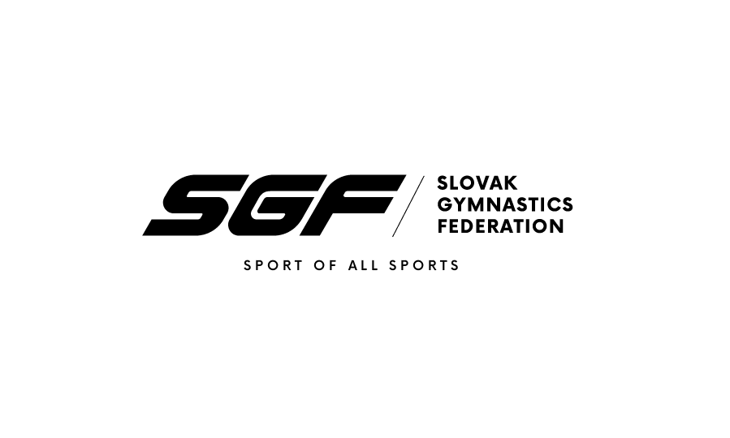

32st GYM – FESTIVAL Trnava 2019
Trnava, (SVK)
1st – 2nd June 2019

Form to be sent to:
Organizing Committee / Host Federation
Slovak Gymnastics Federation
Junácka 6
832 80 Bratislava
Tel: +421917693942
Email: i.barutova@sgf.sk
Deadline: 1st May, 2019
ACCOMMODATION Form

Federation |  | Contact person:
Federation |  | Phone:
Federation |  | E-mail:

Hotel name | Room type  (i.e. single/double/triple/quadruple) | Arr. day | Dept. day | LAST NAME,  First Name | Function | Price per  person per night | # of nights | Total
 |  |  |  |  |  | GRAND TOTAL

Special requirements

Place and date | Seal of the NF | NF authorised signature
 |  | Signature of the President or Secretary General of the participating FIG affiliated NF

