32nd GYM FESTIVAL Trnava 2019
Trnava, (SVK)
1st – 2nd June 2019

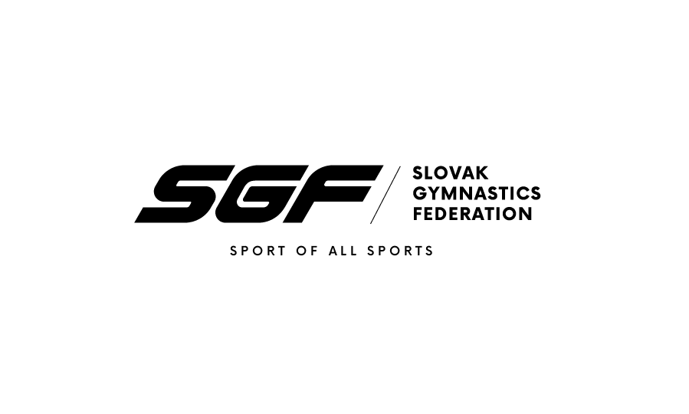

Form to be sent to:
Organizing Committee / Host Federation
Slovak Gymnastics Federation
Junácka 6
832 80 Bratislava
Tel: +421917693942
Email: i.barutova@sgf.sk
Deadline: 1st April 2019

Definitive registration

Federation |  | Contact person:
Federation |  | Phone:
Federation |  | E-mail:

We will participate YES NO

If yes, with the following delegation:
number
WAG SENIOR GYMNASTS……………………………………………………………….
WAG JUNIOR GYMNASTS……………………………………………………………….
WAG GIRLS GYMNASTS………………………………………………………………….
WAG coaches………………………………………………………………………………
WAG judges…………………………………………………………………………………
Additional persons: ………………………………………………………………….……

Place and date | Seal of the NF | NF authorised signature
 |  | Signature of the President or Secretary General of the participating FIG affiliated NF

