32nd GYM FESTIVAL Trnava 2019
Trnava, (SVK)
1st – 2nd June 2019

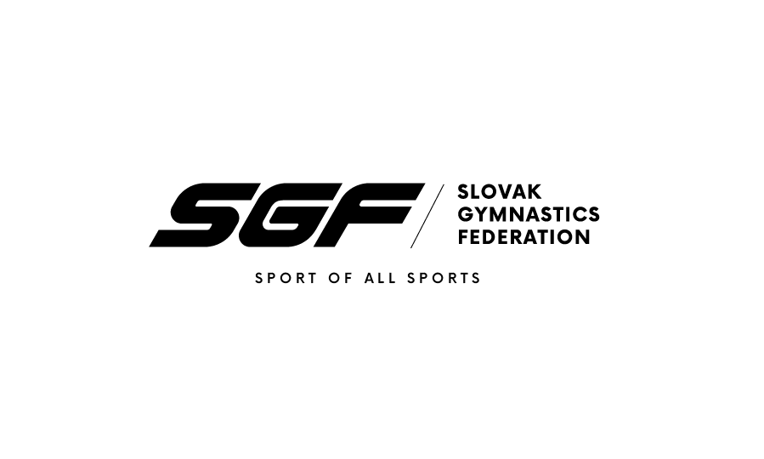
Form to be sent to:
Organizing Committee / Host Federation
Slovak Gymnastics Federation
Junácka 6
832 80 Bratislava
Tel: +421917693942
Email: i.barutova@sgf.sk
Deadline: 1st May, 2019

MEALS Form

Federation |  | Contact person:
Federation |  | Phone:
Federation |  | E-mail:

Date |  | Number
30th May, 2019 / THURSDAY | Lunch
30th May, 2019 / THURSDAY | Dinner
31st May, 2019 / FRIDAY | Lunch
31st May, 2019 / FRIDAY | Dinner
1st June, 2019 / SATURDAY | Lunch
1st June, 2019 / SATURDAY | Dinner
2nd June, 2019 / SUNDAY | Lunch
2nd June, 2019 / SUNDAY | Dinner
3rd June, 2019 / MONDAY | Lunch
3rd June, 2019 / MONDAY | Dinner
 | TOTAL

Place and date | Seal of the NF | NF authorised signature
 |  | Signature of the President or Secretary General of the participating FIG affiliated NF

