

CZECH AEROBIC OPEN 2019
PRAGUE, CZECH REPUBLIC
8th March - 10th March, 2019

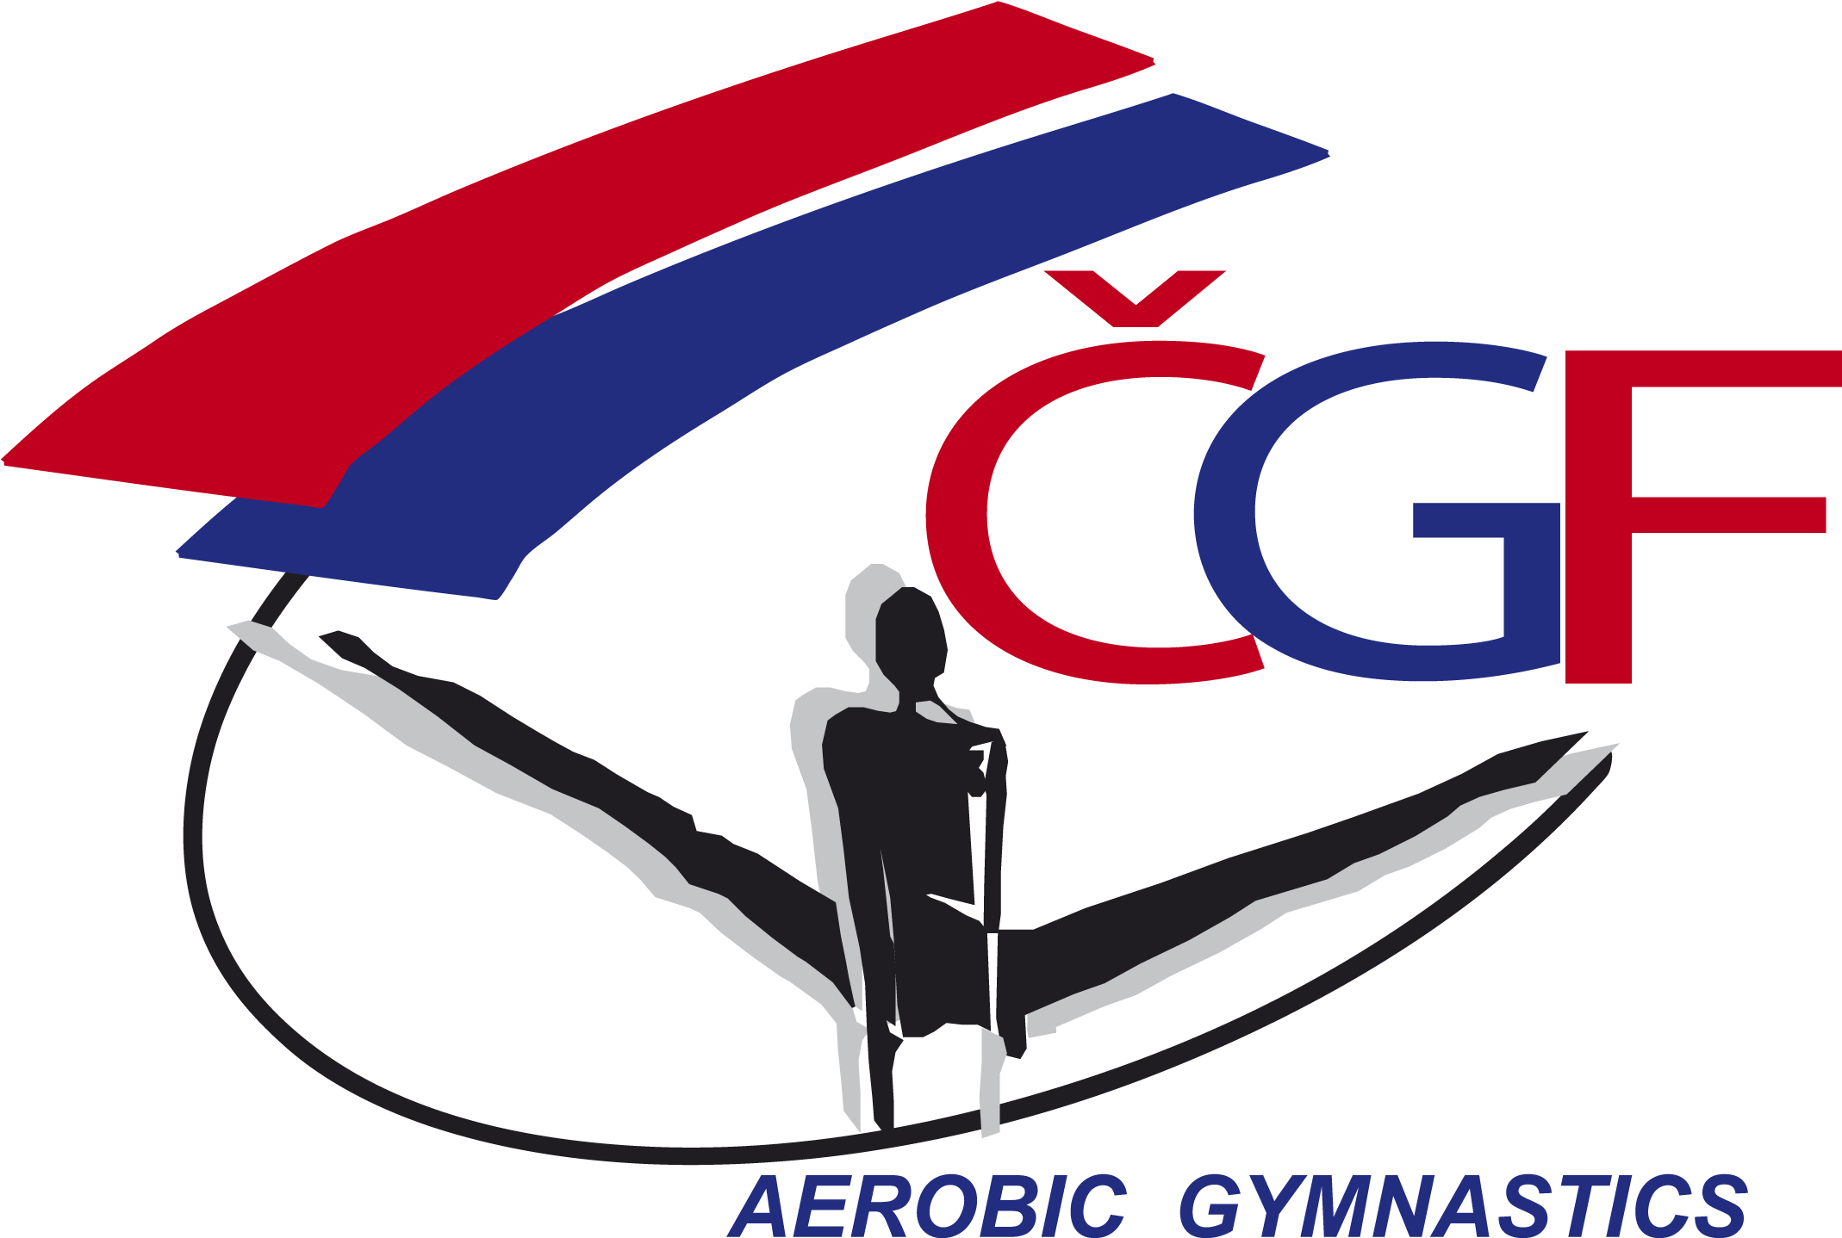

DIRECTIVES

Event ID:
Dear FIG affiliated Member Federation,

The Czech Gymnastics Federation has the pleasure to invite your Federation to participate in the aforementioned official FIG International Event.
Discipline | Aerobic Gymnastics
Host Federation | Czech Gymnastics Federation  Zatopkova 100/2, 160 17 Praha 6  Contact person:  Mrs. Zuzana Vojackova  Phone: +420 242 429 260,  Email: cgf@gymfed.cz  Website: http://www.gymfed.cz
Local OrganizING COMMITTEE | Czech Gymnastics Federation  Zatopkova 100/2, 160 17 Praha 6  Contact person:  Mr. Roman Slavík  Phone: +420 242 429 260, Mobil: +420 739 300 960  Email: slavik@gymfed.cz  Website: http://www.gymfed.cz
LOCATION | Prague, the Czech Republic
Date | From 8th March to 10th March, 2019
Venue | WELNESS HOTEL STEP  Malletova1141/4, 19000 Praha 9  Phone: +420 296 786 100  Email: kongresmanager@hotelstep.cz  Website: http://www.wellness-hotel-step.cz
APPARATUS SUPPLIER | GYMNOVA (Aero Floor One, Ref. 6630)
RULES AND REGULATIONS | The event will be organized under the following FIG rules, as valid in the year of the event, except for any deviation mentioned in these directives:  Statutes  Technical Regulations  - Code of Points and relevant Newsletters  - General Judges’ Rules  - Specific Judges’ Rules  - Doping Control Rules  - Licence rules (except for non competitive events)  - Media Rules  - Apparatus Norms  - FIG Rules for Sanctioning (approval) of International Events  - Advertising and Publicity Rules  and subsequent decisions of the FIG Executive Committee
federations invited | The Organizing Member Federation will invite all FIG Member Federations in good standing.
AGE LIMITS | Aerobic Gymnastic, ND: 9-11 years, AG1: 12-14 years, AG2: 15-17 years, Seniors: 18 year and older  All gymnasts in Age Groups AG2 and Seniors must have a valid FIG licence until the end of the event.
JUDGES AND JURIES | All judges must have a current valid FIG brevet at the time of the event.  Each federation must send at least 1 judge. The number of Judge´s panels will be decided depending on the number of participating competitors and judges.  The Juries will be set by a draw fro the judges present at the event. The priority will be given to the judges of the highest category.
REGISTRATION DEADLINES
  Definitive registration: | 31st January, 2018 | 6 weeks prior to the event
  Nominative registration: | 22nd February, 2019 | 2 weeks prior to the event
ENTRY FEES | The Entry fees for the different categories in each Age Group are as follows:  IW & IM: 20 € / MP 30 € / TR: 50 € / GR: 60 € / DA: 80 € / ST: 80 €  100% of the Entry fee must be paid to the bank account of the Czech Gymnastics Federation on 31^{tst} January, 2019 at the latest (the deadline for the Definitive Entry).
ACCREDITATION | The accreditation will take place at the venue “Wellnes Hotel Step” upon arrival of the delegations. The accreditations will be handed to the Head of delegation. Detailed information about the accreditation procedure will be given with the Work Plan that will be distributed to all participating Federations on 1st March, 2018 at the latest.
Event Format | The competition consists of Qualifications and Finals in Age Groups (SEN, AG2, AG1, ND) and all categories. In case that there are less than 9 participants per category in the Qualifications, Qualification is not necessary.  QUALIFICATIONS:  There is no limit on the number of participants per category and nation in the Qualifications.  FINALS:  The top 8 (eight) competitors from the Qualification in each Age Groups (SEN, AG2, AG1) and category (IW, IM, MP, TR, GR, DA, ST) will take part in the Finals (maximum two per category and nation) plus 3 (three) competitors from organizing Federation in each category if their not qualified to the finals.  For the ND categories will not run Qualification round.
PROVISIONAL Schedule | Thursday, 7th March 2019  - Arrival, Accreditation  Friday, 8th March 2019  - Training possibility, Orientation Meeting, Judges Meeting,  - Competition in category ND(IW, IM, MP, TR, GR)  Saturday, 9th March 2019  - Training possibility, Judges Meeting  - Qualifications in category AG1, AG2 & SEN (IW, IM, MP, TR, GR, DA, ST) Sunday, 10th March 2019  - Training possibility, Judges Meeting  - Finals in category AG1, AG2 & SEN (IW, IM, MP, TR, GR, DA, ST)  -Farewell Banquet Monday, 11th March 2019  - Departure
EVENT MANAGER | Mrs. Roman Slavík  Phone: +420 739 300 960, Email: slavik@gymfed.cz
MEDICAL SERVICES | During all days (training and competition) official medical persons will be present in the training and competition halls.
VISA | Please verify immediately with your travel agent or the Czech Republic Embassy or Consulate in your country if a visa is required for your travel to the Czech Republic. The LOC will be happy to assist each Delegation member with an official invitation letter, provided that the request is made before 8th February, 2019 to the Czech Gymnastics Federation.  The request must include the function, full name, gender, date of birth, citizenship and passport number, passport expiry date, the arrival and departure dates of the Delegation Member as well as the city the visa application support letter must be sent to.
INSURANCE | The Host Federation, the LOC and the FIG will not be held responsible for any liabilities in case of accidents, illness, repatriation and the like.  The FIG Technical Regulations foresee that all participating Federations are responsible for making their own arrangements to have the necessary valid insurance coverage against illness, accidents and for repatriation for all the members of their Delegation.  The LOC will verify the insurance upon arrival of the delegation members (e.g. cover note or photocopy of the valid policy). Delegation members with insufficient insurance cover must inform the LOC in advance.  The LOC will subsequently offer insurance at the Federations own charge. Information about the cost of the insurance will be given with the Work plan.
INternational TRANSPORTATION | The invited participating federations must pay for the travel costs of their delegation members. The Travel Schedule Form must be returned to the LOC by 22st February 2019. If person from one delegation/Federations are arriving and departing with different flights, please fill in separate travel forms for each group of persons and indicate on the travel form the exact number of persons.
LOCAL TRANSPORTATION | The LOC may provide transportation free of charge to all delegation members, who have booked their accommodation through the LOC, from the Prague Václav Havel Airport, Prague Railway Stations and Prague Florenc Bus Station to the their hotel and back on the official arrival and departure days.
ACCOMMODATION | Clarion Congress Hotel Prague****  Freyova 33, 190 00 Praha 9  Web site: http://www.clarioncongresshotelpargue.com  The costs per person /night in this first Hotel are as follows:  90 € (Single room, including breakfast)  100 € (Double room, including breakfast)  Wellnes Hotel Step****  Malletova1141/4, 190 00 Praha 9  Web site: http://www.wellness-hotel-step.cz/  The costs per room /night are as follows:  70 € (Single room, including breakfast)  80 € (Double room, including breakfast)  110 € (Triple room, including breakfast)  Relax Inn ****  Novovysocanska 163/254, 190 00 Praha 9  Web site: http://www.relaxinn.cz/  The costs per room /night are as follows:  60 € (Single room, including breakfast)  70 € (Double room, including breakfast)  90 € (Triple room, including breakfast)  Hotel Harfa***  Drahobejlova 1058/17, 190 00 Praha 9  Web site: http://www.hotel-harfa.cz/  The costs per room /night are as follows:  50 € (Single room, including breakfast)  70 € (Double room, including breakfast)  90 € (Triple room, including breakfast)  120 € (Quadruple room, including breakfast)  Hotel Penzion Praga***  U Lidoveho domu 857/11, 190 00 Praha 9  Web site: http://www.penzion-praga.com/  The costs per room /night are as follows:  60 € (Double room, including breakfast)  100 € (Apartment for 5 persons, including breakfast)  The prices charged for the hotel rooms will not exceed the usual hotel rates.  While the Provisional Accommodation Form must be returned to the LOC by 31st January, 2019 at the very latest, the Hotel rooms will be allocated on a “first come, first serve” basis.  The invited participating federations must pay for the accommodation expenses of their delegation members.  The 100% costs for the accommodations must be paid to the LOC by 22nd February 2019.
MEALS | During the competition lunch and dinner are available at the Wellness Hotel Step (Mallatova 1141/4, 19000 Praha 9) close to the competition hall.  Lunch 15 €  Dinner 15 €  The invited participating federations must pay for the meals expenses of their delegation members.  The 100% costs for the meals must be paid to the LOC by 22nd February 2019.
CANCELATION POLICY | In case of room cancellations until 8th February 2019, the LOC will refund 100% of the amount of annulled rooms.  In case of room cancelations until 22nd February 2019, the LOC will refund 50% of the amount of annulled rooms.  In case of room and meals cancellations after 22nd February 2019, no claims of refunds will be accepted.
BANK ACCOUNT INFORMATION | Account Name: CESKA GYMNASTICKA FEDERACE  Bank Name: MONETA MONEY BANK a.s.  Bank Address: Vitezne namesti 577/2, 160 00 Praha 6  Account Nr.: 1724809504/0600  IBAN: CZ64 0600 0000 0017 2480 9504  BIC: AGBACZPP  Each participating member Federation is kindly requested to integrate the payment’s purpose as follows: CZECH AER OPEN  The participating federation is responsible for covering all bank fees in connection with the bank transfers.
Marketing | FIG advertising and publicity norms must be respected.
Media | The Media Officer of the Czech Gymnastics Federation will be present. Email: cgf@gymfed.cz  The national and local media will report the event. TV broadcast will be provided as well. More information at www.gymfed.cz
Social Media | https://www.facebook.com/CeskaGymnastickaFederace
DEADLINES SUMMARY | The forms should be sent to the LOC and the Czech Gymnastics Federation as specified below within the respective deadlines.  The LOC and the Czech Gymnastics Federation: slavik@gymfed.cz
  Definitive Registration | 31^{tst} January, 2019
  Nominative Registration | 22st February, 2019
  Provisional Accommodation Form | 31^{tst} January, 2019
  Detailed Accommodation Form | 22st February, 2019
  Detailed Meals Form | 22st February, 2019
  Travel Schedule Form | 22st February, 2019
  Visa Request Form | 8th January, 2019
  Payment of the Accommodation Costs | 22st February, 2019
  Payment of the Meals Costs | 22st February, 2019
  Payment of the Entry Fee | 31^{tst} January, 2019
ADDITIONAL INFORMATION | Detailed information about the program, schedules and organization of the event will be given to the Work Plan and will be send to all participating Federations after the nominative registration deadline, on 3rd March, 2019 at the latest.  The Draw for the Qualifications and Finals will be done by the LOC until 3rd March, 2019 according to the received Nominative Entries. The Draw will be distributed to all participating Federations together with the Work Plan.

If you have any questions, please don´t hesitate to contact us.
Looking forward to welcome you to the Czech Aerobic Open 2019.
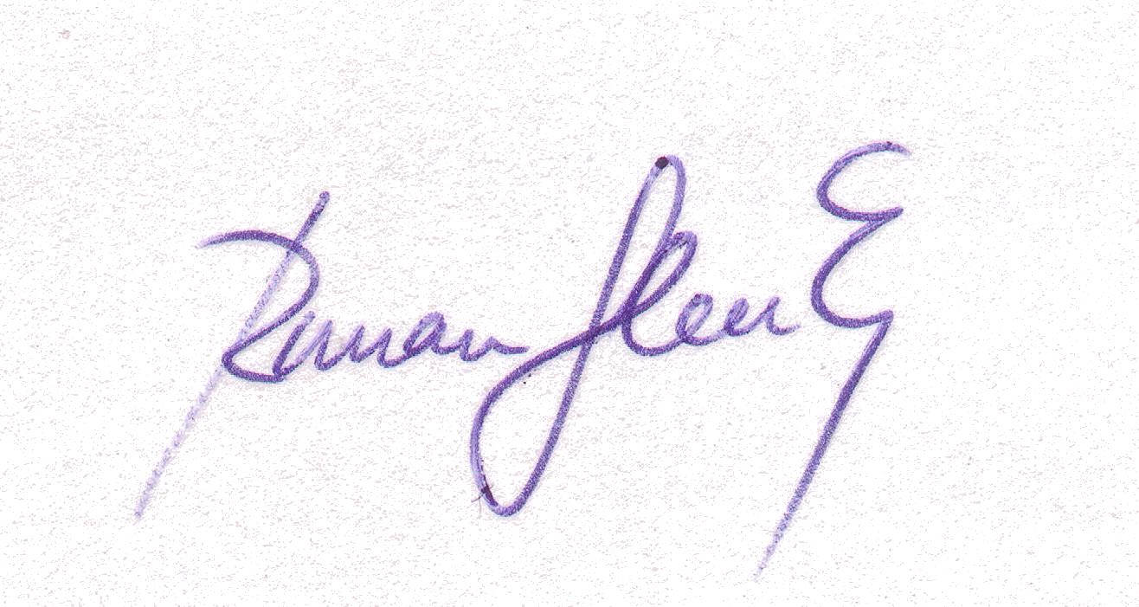
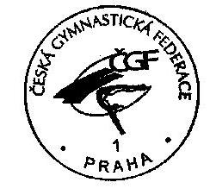
Sincerely Yours,

Signature of the President
Prague, 21-12-2018 of the Czech Gymnastics Federation

