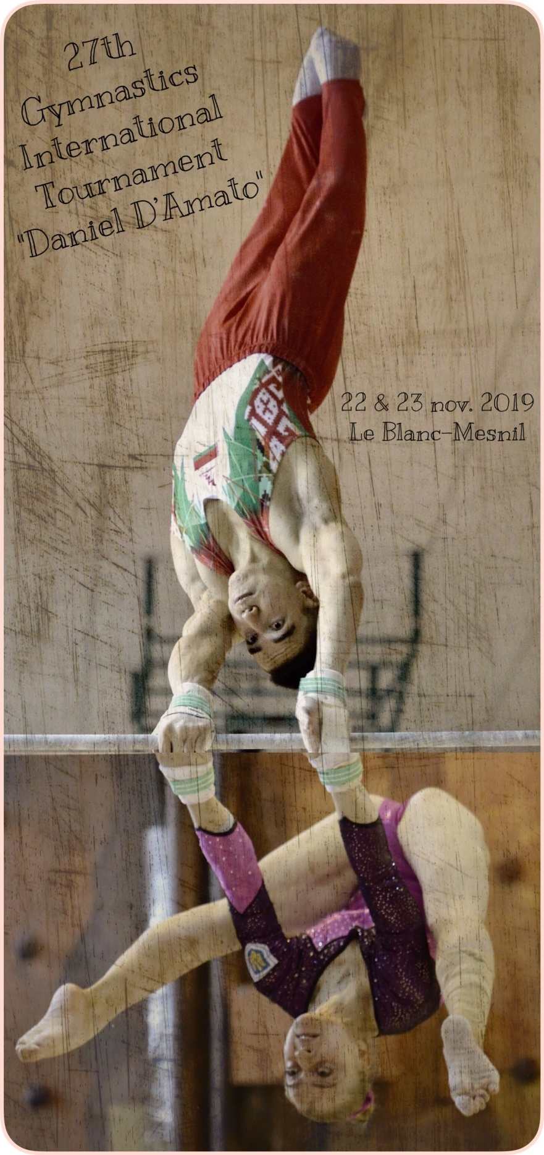

BLANC MESNIL SPORT GYMNASTIQUE
Siège Social et Adresse Postale : 44, Avenue Baptiste Hurel, 93150 Le Blanc-Mesnil
Site Internet : www.bmsgymnastique.fr et www.bmstournoidamato.fr

Dear President(s), Dear friend(s)

Blanc-Mesnil Sport Gymnastique is very proud to announce that a new edition of the Daniel D’Amato International Artistic Gymnastics Tournament will take place next November.
We would be very happy to welcome you and your team(s) and share with you memorable moments of sport and friendship.
We hope you can take part in the coming 27th Blanc-Mesnil International Tournament on November, 22nd & 23rd, 2019.
Please find enclosed the presentation file for the event.
Should you wish to take part, please let us know by filling the form at the end of this document and by sending it to us.
You can also visit à web site www.bmstournoidamato.fr where you will find the results and photos of the previous editions as well as our innovations for this edition and hopefully those to come.

Best regards.

Isabelle DOUCET
President of BMS Gymnastique

Summary

Schedule  Delegation composition  Stay  Geographic location  Technical rules  Tournament fees  Registration form  Travel form  Delegation composition form | Page 4  Page 5  Page 6  Page 8  Page 9  Page 10  Page 11  Page 12  Page 13

SCHEDULE

- Thursday November 21st 2019

Delegations arrival
Optional training session 14h00 to 17h00
Information meeting at the hotel (judges and coaches) at 19h00

- Friday November 22nd 2019

Optional training session 9h00 to 12h00
20h00: Tournament kickoff (Qualifiers)
- Saturday November 23rd 2019

09h30 Meeting with the coaches for the selection of finalists
15h00: Apparatus finals
Around 20h30: Party (All delegation members are invited)

Sunday November 24th 2019

Delegations departure

Concerning eventual tourist sightseeing,
we offer to drive you to the nearest train station
(20 min from Paris centre).

DELEGATION COMPOSITION

We offer to participate in the 27th International Gymnastics Tournament Daniel D’Amato
of Blanc-Mesnil with a mixed delegation or an only male or female delegation.

Mixed delegation:
Maximum 11 people:

- 1 delegation chief
- 3 female gymnasts F.I.G. licensed (juniors and / or seniors)
- 1 female coach
- 1 female judge
- 3 male gymnasts F.I.G. licensed (juniors and / or seniors)
- 1 male coach
- 1 male judge

Female or male delegation:

Maximum 6 people:

- 1 delegation chief
- 3 gymnasts F.I.G. licensed (juniors and / or seniors)
- 1 coach
- 1 judge

ADMINISTRATIVE CONDITIONS

The registration to the 27th International Gymnastics Tournament is free.

Insurance:

All gymnasts will have to be insured by their home Gymnastics Federation.

STAY

All the delegations will be supervised by the Blanc-Mesnil Gymnastics Club.
Any arrival before the scheduled date will be at the expense of the delegation.
(hotel and catering).

PAID EXPENSES
Blanc Mesnil Sport Gymnastique will partially support your accommodation and catering,
a participation will be required.
Delegations will pay and organize their transport

- Welcome

- Each delegation will be welcomed upon arrival at the airport or train station.
Local transfers (gym / hotel) will be provided by the members of the Organizing Committee.

- Stay

- Accommodation site (to be specified later)

- Hotel stay (Full board **) you will be required to participate 30 euros*** per person. Only the delegation members as described above (6 or 11 people) will be taken care of Thursday November 21st at noon until Sunday, November 24th morning.

- Accommodation and meals will not paid*** for any additional people (gymnasts, parents, staff…).
An additional 25 euros*** will be paid to attend the closing gala.

** Beverages are not included with meals and any extra will be charged.
*** To be paid before your arrival.

- Compétition

- Competition location:
Gymnasium Auguste Delaune
Stade Jean Bouin
106, Avenue Charles Floquet
93150 Le Blanc-Mesnil

A kinesitherapist will be present during competition.

BLANC MESNIL GEOGRAPHIC LOCATION
Le Blanc-Mesnil is located 10 km North East of Paris, 20 minutes from Paris (Gare du Nord)
City of 52 797 inhabitants, spanning over 800 Acres.
Highways A1, A3 and A104 and Nationals 2 and 17
Roissy Charles de Gaulle airport (10 min away) and Le Bourget airport (2 min away and 7 min from Paris)
RER subway station (line B Roissy – Paris) and 6 bus lines.
The Forum: A cultural regional space
The largest urban park in the Paris region
1st prize for environment in the Paris region in 2004
Le Blanc-Mesnil is an entry point to the 1st airport and business platform in Europe
PARIS AND ITS MONUMENTS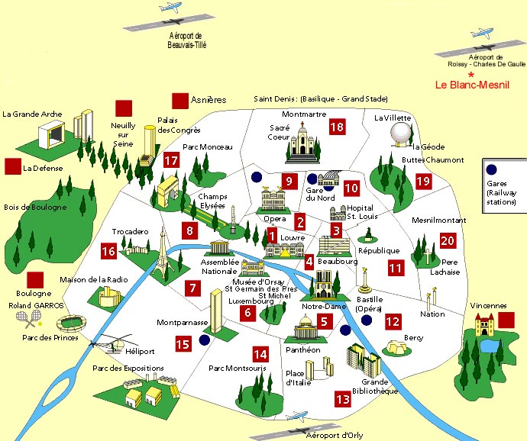

TECHNICAL RULES

Free routine competition Course 1 (Senior F.I.G scoring)
Female and male apparatus.

- Judging

All French judges convened to the Tournament are national or international judges.
(Level 4 and 5)

Prior judges repartition is made by the Ile de France Zone Representatives.

The choice of apparatus to be judged as well as your choice between Expert judge (Jury D)
and Execution judge (Jury E) will be requested upon arrival.

Juries composition Friday : 2x D judges / 2x E judges for each apparatus.
Saturday : 2x D judges / 4x E judges for each apparatus.

Level required Level 4 minimum (male and female).
- Ranking

Female team : Addition of the two best female scores by apparatus.

Male team : Addition of the two best male scores by apparatus.
Individual : Vertical ranking

- Prizes

By team: Trophy or cup for the first three teams

Individual: Trophy or cup
Fee for the first three female and first three male competitors.
By apparatus : Trophy or cup
Fee for the first three female and first three male competitors

TOURNAMENT FEES

GENERAL INDIVIDUAL RANKING
 | FEMALE | MALE
1st PLACE | 450 € | 450 €
2nd PLACE | 300 € | 300€
3rd PLACE | 150 € | 150 €

PRIZES AWARDED FOR THE APPARATUS FINALS *
 | FEMALE | MALE
1th PLACE | 170 € | 170 €
2nd PLACE | 130 € | 130 €
3rd PLACE | 100 € | 100 €

* A female gymnast can get two prizes to the maximum, a male gymnast can get up to three

REGISTRATION FORM
Deadline September 14th 2019

FEDERATION
COUNTRY
NAME & ADDRESS, MOBILE PHONE NUMBER OF CONTACT
TEL
FAX
E-MAIL

We would like to participate in the 27TH International Tournament Daniel D’Amato with a:

Mixed delegation | YES * | NO *
Female delegation | YES* | NO*
Male delegation | YES* | NO*

* Please cross out the unnecessary text.

We hereby agree to abide by the conditions of the 27th International Artistic Gymnastics Tournament Daniel D’Amato of Blanc-Mesnil. In case of misconduct, the members or the Organization Committee have the right to cancel the participation of our delegation to the Tournament.
Signature after having read the complete rules

Please be as precise as possible when completing this form. Thank you.

Youri ASTACHEV, 6 rue Paul Langevin, Appart. 136,
94120 Fontenay Sous Bois. France.
Tel & Fax : 01.48.73.15.86 / E-mail : astachev@orange.fr

