
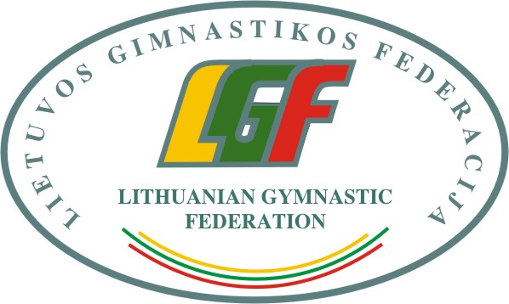our event

3rd International Aerobic Gymnastics Competition “Lithuanian Open CHAMPIONSHIP 2020“, 21-22nd February 2020

Form to be sent to:
Organizing Committee / Host Federation
Lithuanian Gymnastics Federation
Contact person: Algimantas Prunskas
E-mail: info@gimnastika.lt
Deadline: 20th December 2019
ACCOMMODATION Form

Federation |  | Contact person:
Federation |  | Phone:
Federation |  | E-mail:

Package / Hotel name | Room type  (i.e. single/double/triple/quadruple) | Arr. day | Dept. day | LAST NAME,  First Name | Function | Price per  person per night | # of nights | Total
 |  |  |  |  |  | GRAND TOTAL

Special requirements

Place and date | Seal of the NF | NF authorised signature
 |  | Signature of the President or Secretary General or Head of Club of the participating FIG affiliated NF

