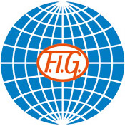
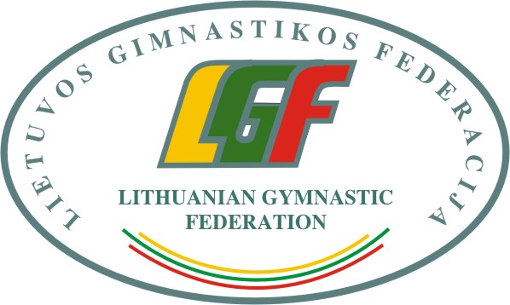

3rd International Aerobic Gymnastics Competition “Lithuanian Open CHAMPIONSHIP 2020“, 21-22nd February 2020

Form to be sent to:
Organizing Committee / Host Federation
Lithuanian Gymnastics Federation
Contact person: Algimantas Prunskas
E-mail: info@gimnastika.lt
Deadline: 20th December, 2019

Definitive registration

Federation |  | Contact person:
Federation |  | Phone:
Federation |  | E-mail:

Category - Seniors | Number of participans

Individual Woman
Individual Man

Mixed pair
Trio
Groups
Category – Age Group 15-17 | Number of participants

Individual Woman
Individual Man

Mixed pair
Trio
Groups
Category – Age Group 12-14 | Number of participants
Individual Woman
Individual Man
Mixed pair
Trio
Groups
Officials | Number of officials
Judges
Head of delegation
Coaches
Doctor / Therapist

Place and date | Seal of the NF | NF authorised signature
 |  | Signature of the President or Secretary General or Head of Club of the participating FIG affiliated NF

