
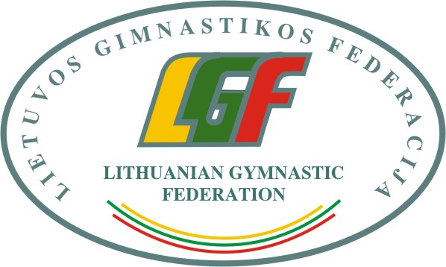

3rd International Aerobic Gymnastics Competition “Lithuanian Open CHAMPIONSHIP 2020“, 21-22nd February 2020

Form to be sent to:
Organizing Committee / Host Federation
Lithuanian Gymnastics Federation
Contact person: Algimantas Prunskas
E-mail: info@gimnastika.lt
Deadline: 20th January 2020
Travel Schedule Form

Federation |  | Contact person:
Federation |  | Phone:
Federation |  | E-mail:
If the team delegation is scheduled on more than one transportation mean, please complete one (1) form for
each transportation mean. For earlier arrival or later departure please contact the OC.
Arrival information
# of persons |  |  | # of luggage
Date: |  |  |  |  | Arrival time
By airplane | Airport: |  |  | Flight # |  | From
By train | Station: |  |  | Train # |  | From
By bus (complete if needed) | Station: |  |  | Bus # |  | From
By car

Departure information
# of persons |  |  | # of luggage
Date: |  |  |  |  | Departure time
By airplane | Airport: |  |  | Flight # |  | To
By train | Station: |  |  | Train # |  | To
By bus (complete if needed) | Station: |  |  | Bus # |  | To
By car

Place and date | Seal of the NF | NF authorised signature
 |  | Signature of the President or Secretary General or Head of Club of the participating FIG affiliated NF

