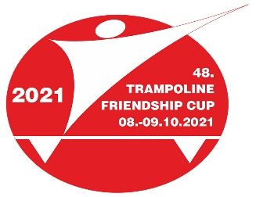
PRE-EVENT HEALTH QUESTIONNAIRE

Event | 48th International Trampoline Friendship Cup  Jablonec nad Nisou, CZE, 7.-10.10.2021
Last name, First name
Delegation of
Phone number
(including country code)
Email address
Countries visited during the last two weeks

Within the past 14 days before the beginning of the event, have you… | YES | NO
Had close contact with anyone diagnosed as having Coronavirus disease COVID-19?
Provided direct care for COVID-19 patients?
Visited or stayed in a closed environment with any patient having
Coronavirus disease COVID-19?
Worked together in close proximity, or sharing the same classroom environment with a COVID-19 patient?
Travelled together with a COVID-19 patient in any kind of conveyance?
Lived in the same household as a COVID-19 patient?
Been in quarantine?
Tested positive to the swap PCR test?

Have you experienced any of the following symptoms now and in  the previous 14 days before the beginning of the camp: | YES | NO
Fever
Cough
Fatigue
Dyspnoea (difficulty in breathing)
Myalgia (muscle aches)
Sore Throat
Chest Pain
Congestion/Coryza (runny nose)
Headache
Chills
Nausea/Vomiting
Diarrhoea
Anosmia/Dysgeusia (loss of taste)
Chilblains/Pernio (painful swelling of the hands)

Signature of the person (for minors: signature of a parent / legal representative)

