2021 6th Korea Open Aerobic Competition SEOUL (KOR)
12 – 13 July, 2021

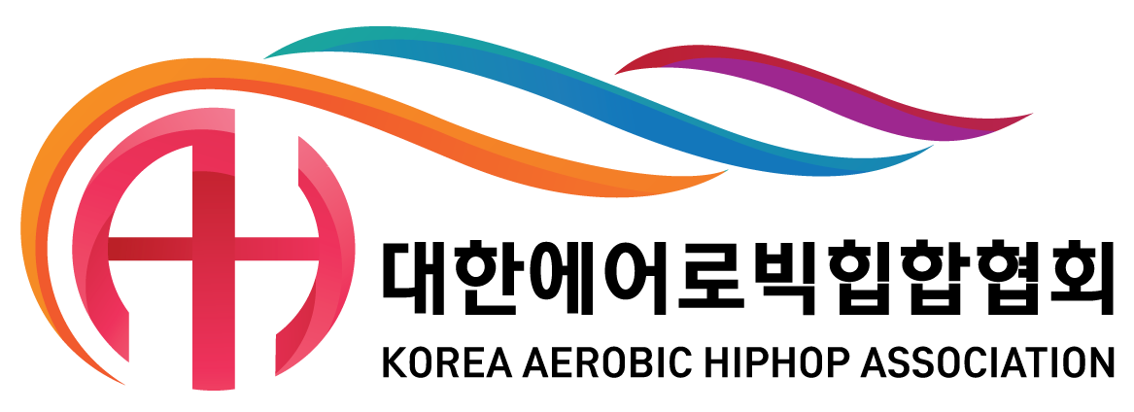

Organizing Committee / National Federation
Korea Aerobic Association
Contact person : Mr. Albert CHUNG
Tel.: + 82 2 742 8782, Fax.: + 82 2 420 2291
e-mail : kaa@aerobic.or.kr
Deadline: 15th June 2021

Nominative registration

Federation |  | Contact person:
Federation |  | Phone:
Federation |  | E-mail:

Categories |  | Age Group | Last Name | First Name | Date of birth
Individual Woman 1
Individual Woman 2
Individual Man 1
Individual Man 2
Mixed Pair 1 | 1.
 | 2.
Trio 1 | 1.
 | 2.
 | 3.
Group | 1.
 | 2.
 | 3.
 | 4.
 | 5.
Aerobic Dance | 1.
 | 2.
 | 3.
 | 4.
 | 5.
 | 6.
 | 7.
 | 8.
Aerobic Step | 1.
 | 2.
 | 3.
 | 4.
 | 5.
 | 6.
 | 7.
 | 8.
- Age group : ND(National Development), AG1(Age Group1), AG2(Age Group2), SEN(Senior)
 |  | Last Name | First Name | FIG-Brevet Level
Judges | 1.
 | 2.

Head of Delegation
Coach
Additional person 1
Additional person 2

Total number in delegation

