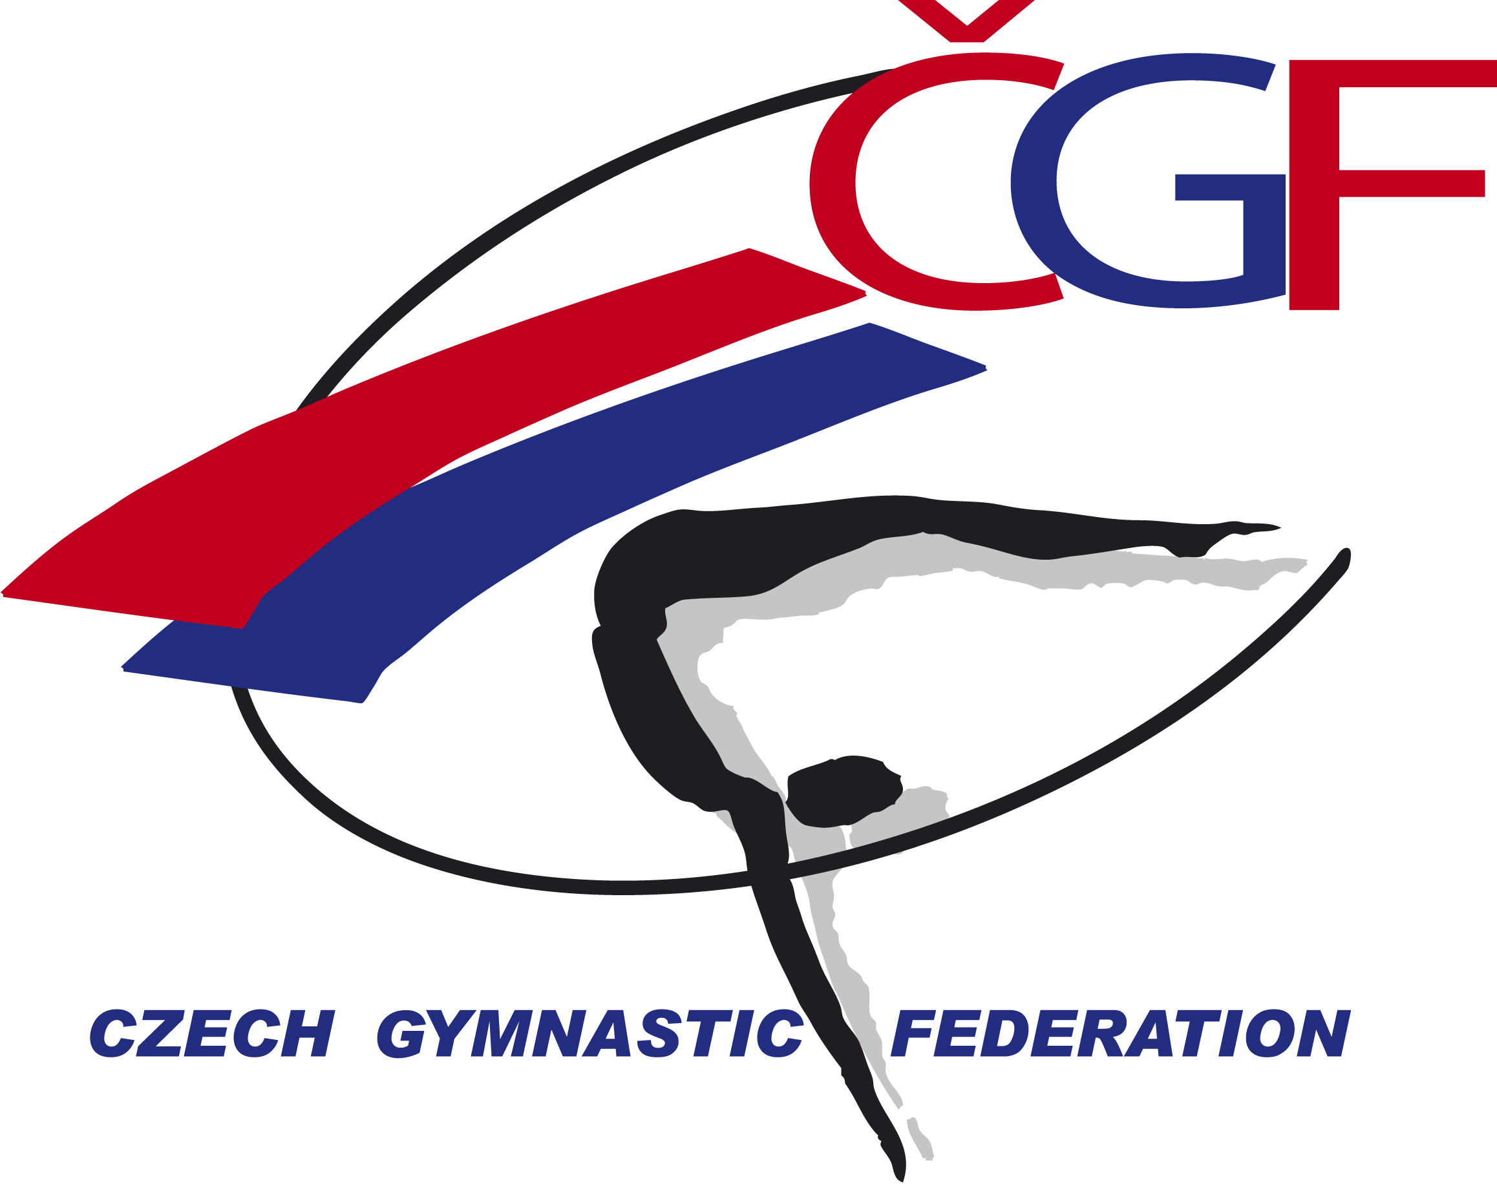

VĚRA ČÁSLAVSKÁ GRAND PRIX 2022
(Youth Olympic Hopefuls´ Competition)
Brno - Czech Republic
November 12th – November 13th, 2022
Form to be sent to:

Host Federation
Czech Gymnastics Federation
Zatopkova 100/2, 160 17 Praha 6
Phone: +420 242 429 260
Roman Slavík +420 739 300 960
Emai: cgf@gymfed.cz
Deadline: October 21st 2022
ACCOMMODATION Form

Federation |  | Contact person:
Federation |  | Phone:
Federation |  | E-mail:

Package / Hotel name | Room type  (i.e. double/triple/quadruple/six beds) | Arr. day | Dept. day | LAST NAME,  First Name | Function | Price per  person per night | # of nights | Total
HOTEL CONTINENTAL
 |  |  |  |  |  | GRAND TOTAL

Special requirements

Place and date | Seal of the NF | NF authorised signature
 |  | Signature of the President or Secretary General of the participating FIG affiliated NF

