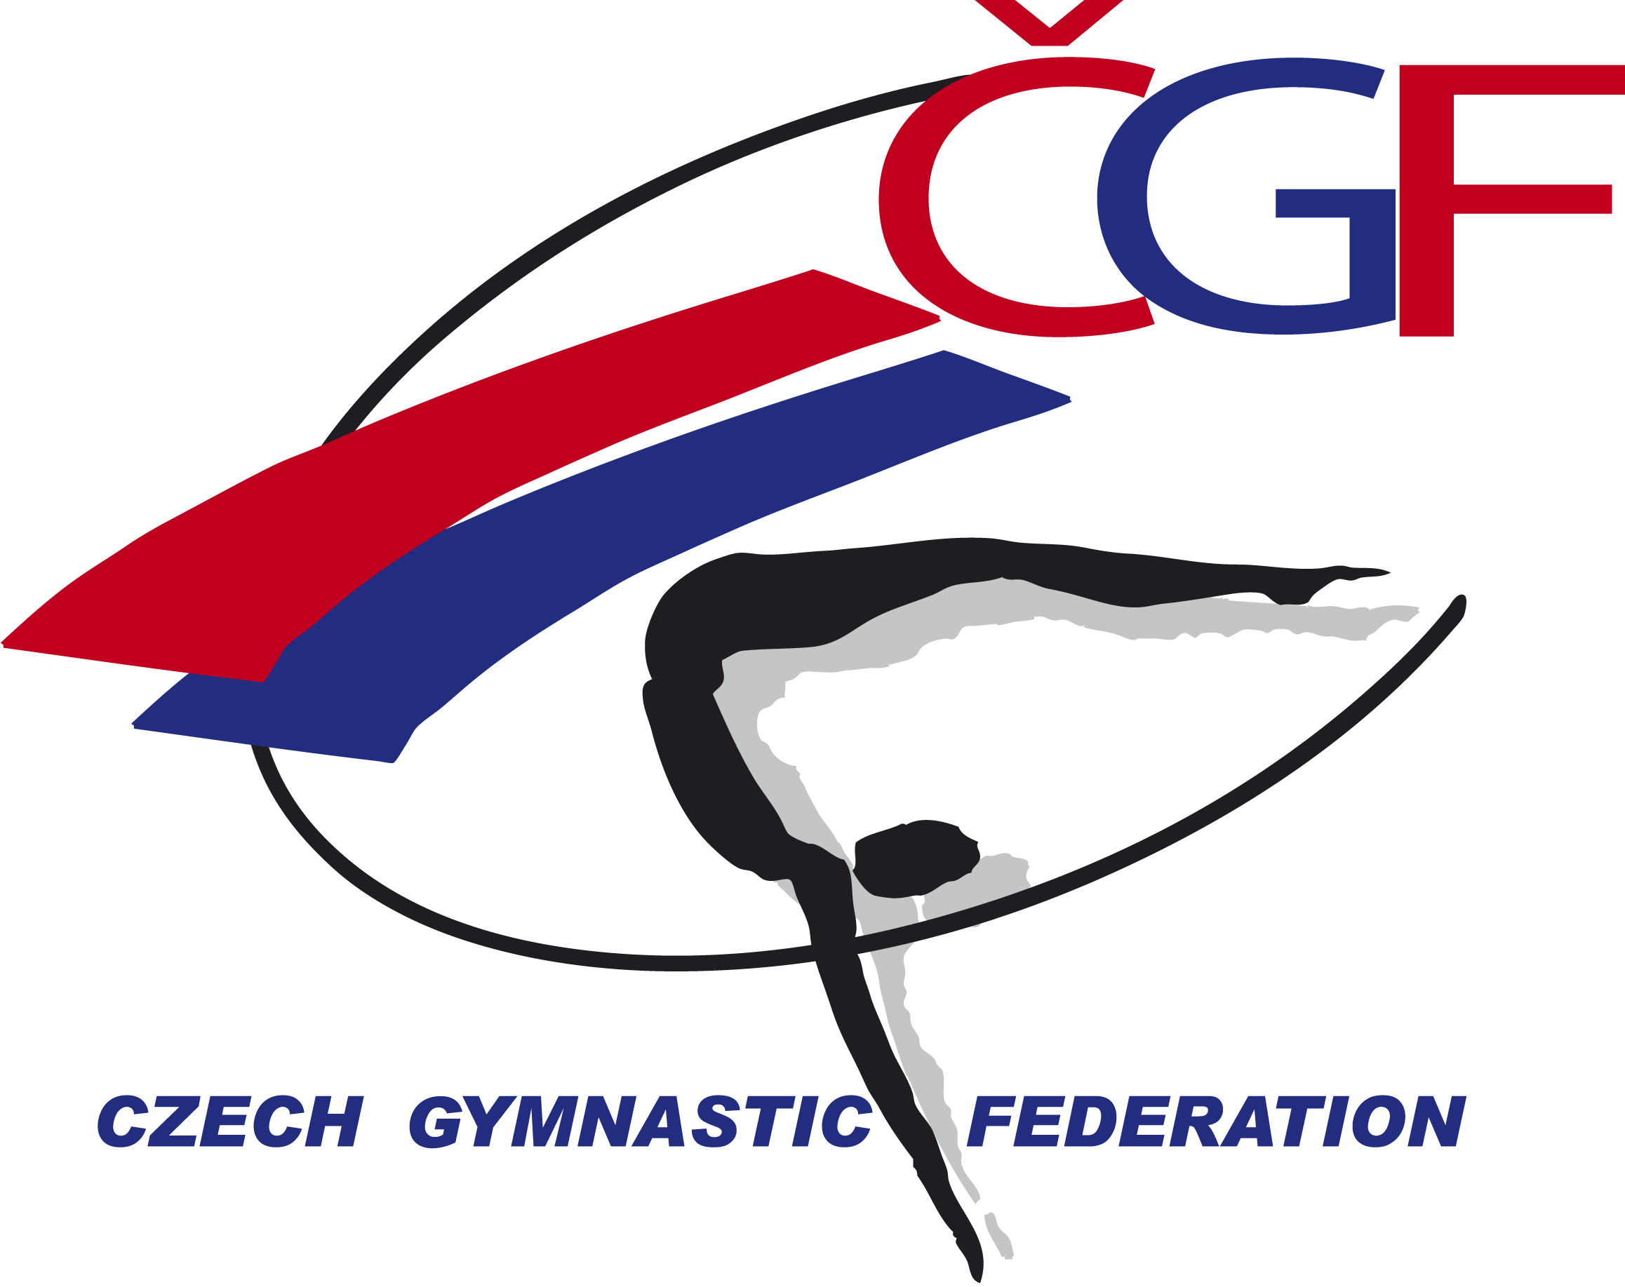

VĚRA ČÁSLAVSKÁ GRAND PRIX 2022
(Youth Olympic Hopefuls´ Competition)
Brno – Czech Republic
November 12th – November 13th 2022

Form to be sent to:
Host Federation
Czech Gymnastics Federation
Zatopkova 100/2, 160 17 Praha 6
Phone: +420 242 429 260
Email: cgf@gymfed.cz
Contact person: Roman Slavík +420 739 300 960
Deadline: September 21^{tst} 2022

DEFINITIVE REGISTRATION

Federation
Contact Person | Last name: |  | First name:
Address | Street: |  | Post Office Box:
Address | ZIP/Postcode: | Place: |  | Country:
Telephone / Fax | Telephone: | Mobile: |  | Fax:
E-mail

WE WILL PARTICIPATE YES NO

MALE GYMNASTS YES NO NUMBER

FEMALE GYMNASTS YES NO NUMBER

MAG COACHES YES NO NUMBER

WAG COACHES YES NO NUMBER

MAG JUDGES YES NO NUMBER

WAG JUDGES YES NO NUMBER

Place and date | Seal of the NF | NF authorised signature
…………………………………………….. |  | ……………………………………………..  Signature of the President or Secretary General of the FIG affiliated NF.

