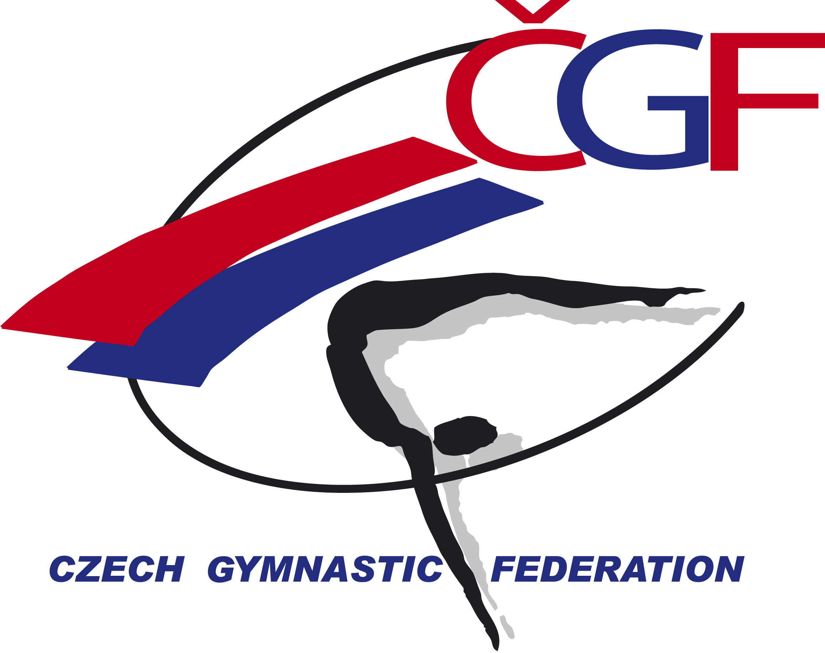
VĚRA ČÁSLAVSKÁ GRAND PRIX 2022
(Youth Olympic Hopefuls´ Competition) Brno – Czech Republic
November 12th – November 13th , 2022



Form to be sent to:
Host Federation
Czech Gymnastics Federation
Zatopkova 100/2, 160 17 Praha 6
Phone: +420 242 429 260
Email: cgf@gymfed.cz
contact person: Roman Slavík +420 739 300 960
Deadline: October 21st 2022
Travel Schedule Form

Federation |  | Contact person:
Federation |  | Phone:
Federation |  | E-mail:
If the team delegation is scheduled on more than one transportation mean, please complete one (1) form for
each transportation mean. For earlier arrival or later departure please contact the OC.
Arrival information
# of persons |  |  | # of luggage
Date: |  |  |  |  | Arrival time
By airplane | Airport: |  |  | Flight # |  | From
By train | Station: |  |  | Train # |  | From
By bus (complete if needed) | Station: |  |  | Bus # |  | From
By car

Departure information
# of persons |  |  | # of luggage
Date: |  |  |  |  | Departure time
By airplane | Airport: |  |  | Flight # |  | To
By train | Station: |  |  | Train # |  | To
By bus (complete if needed) | Station: |  |  | Bus # |  | To
By car

Transport from Prague Airport to Liberec and back - 70 € per person. | Number |  | Total

Place and date | Seal of the NF | NF authorised signature
 |  | Signature of the President or Secretary General of the participating FIG affiliated NF

