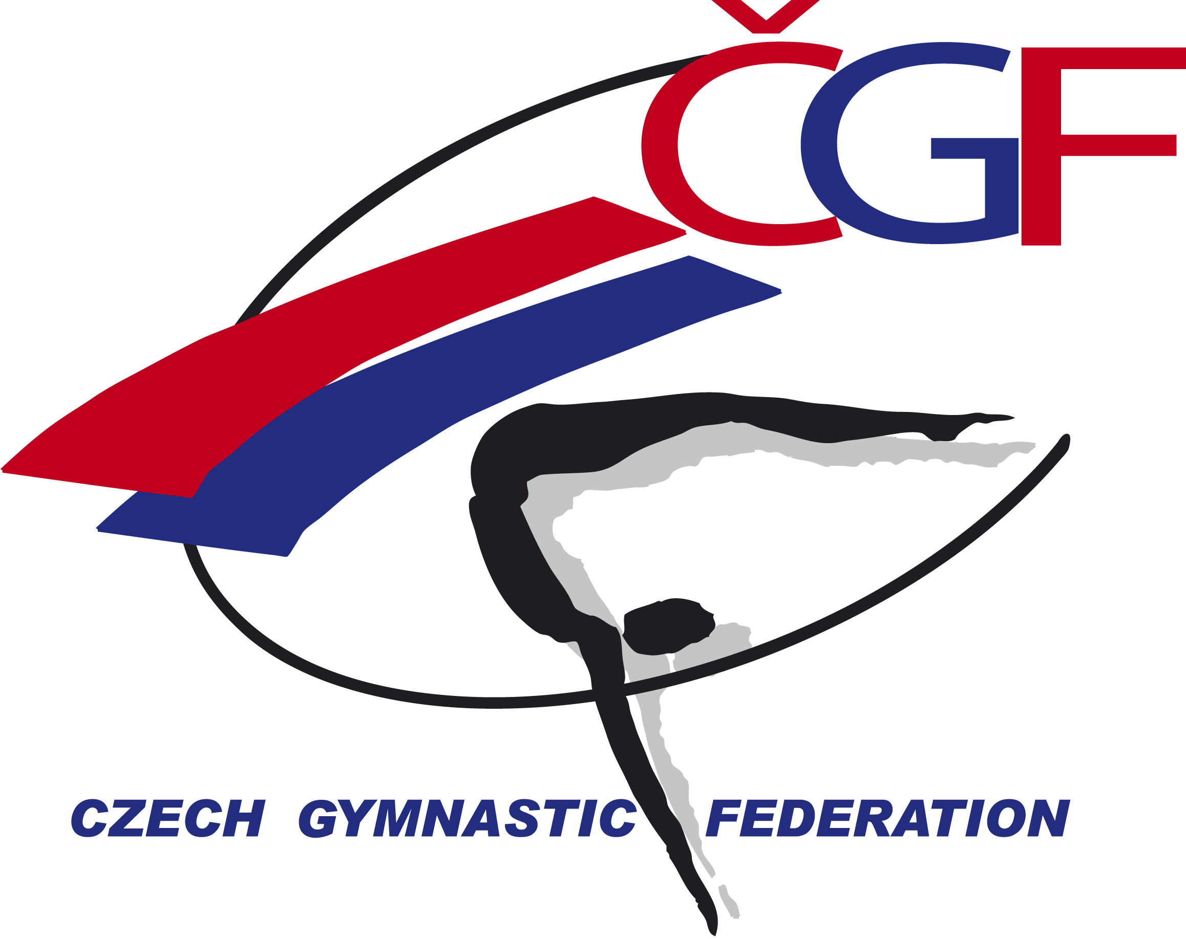

VĚRA ČÁSLAVSKÁ GAND PRIX 2022
(Youth Olympic Hopefuls´ Competition)
Brno – Czech Republic
November 12th – November 13th, 2022

Form to be sent to:
Host Federation
Czech Gymnastics Federation
Zatopkova 100/2,160 17 Praha 6
Phone: +420 242 429 260
Email: cgf@gymfed.cz
Contact person: Roman Slavík +420 739 300 960
Deadline: October 15th, 2022
VISA REQUEST Form

Federation |  | Contact person:
Federation |  | Phone:
Federation |  | E-mail:

LAST NAME,  First name | Function | Gender  M/F | Date of birth  dd.mm.yyyy | Email | Phone number | Citizenship and  passport N° | Passport expiry date | Arrival date | Departure date | City*
* city where the visa application support letter must be sent to
Place and date | Seal of the NF | NF authorised signature
 |  | Signature of the President or Secretary General of the participating FIG affiliated NF

