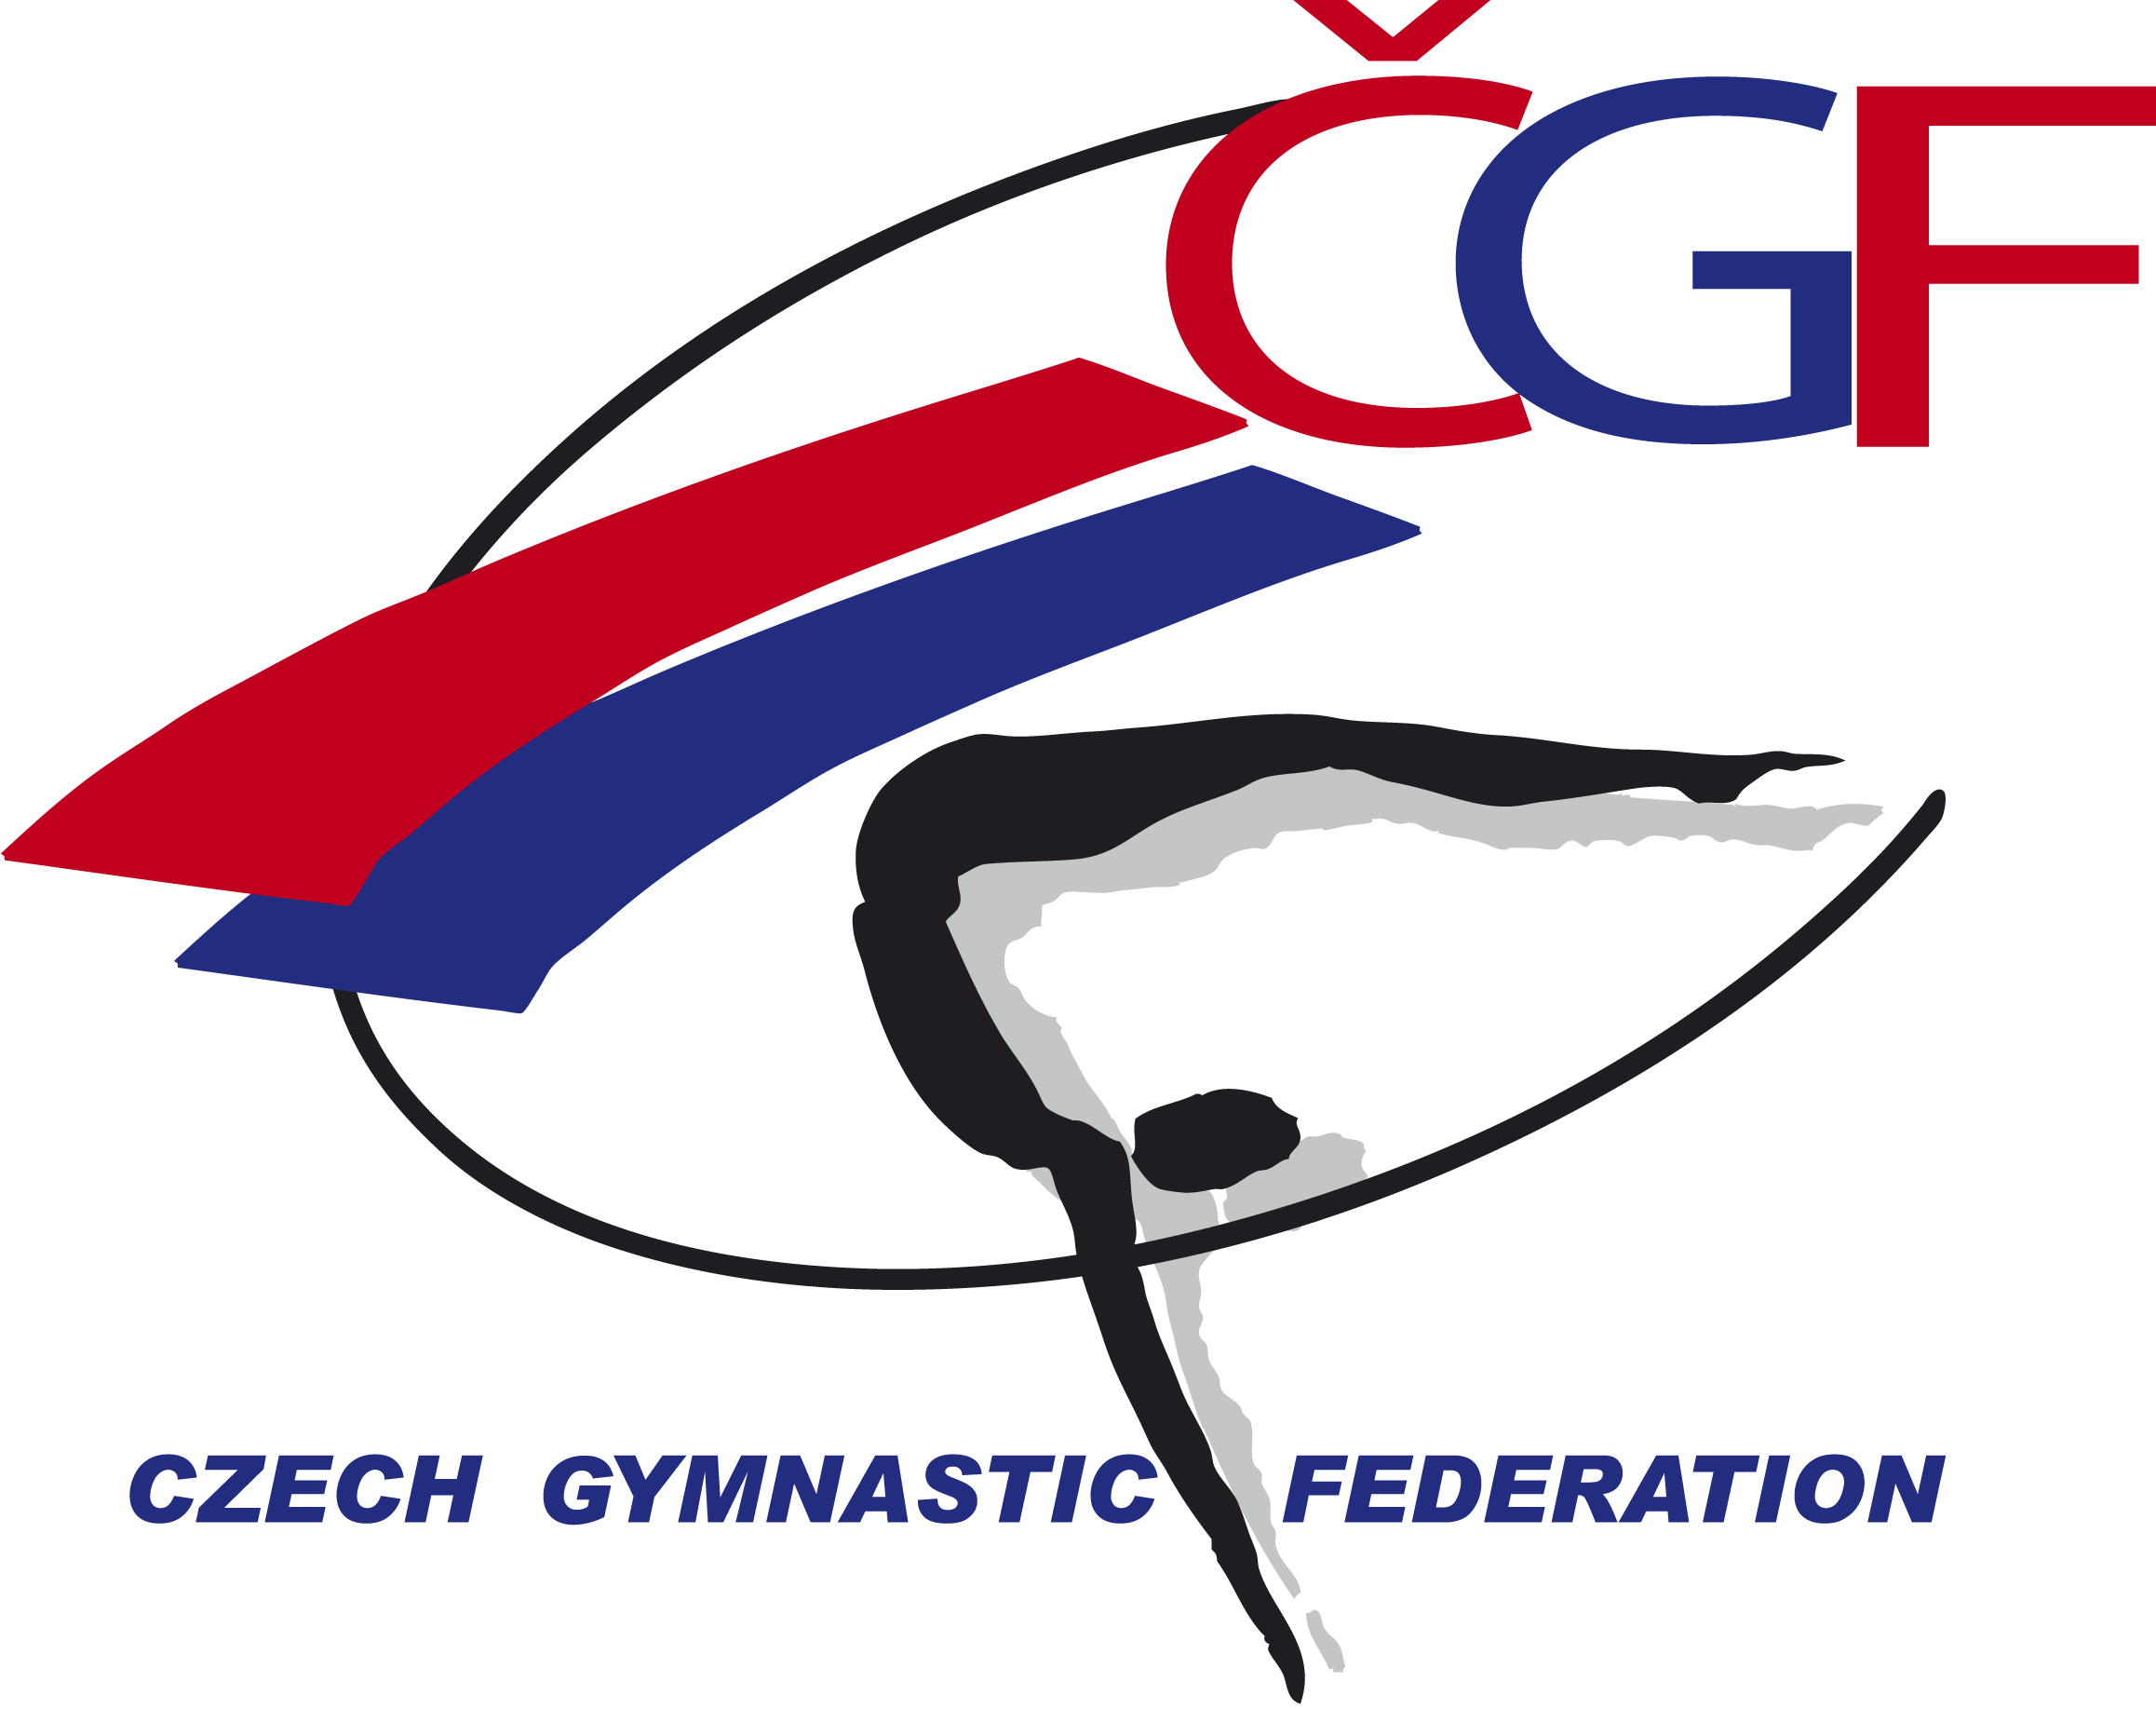

VĚRA ČÁSLAVSKÁ GRAND PRIX 2022
(Youth Olympic Hopefuls´ Competition) Brno – Czech Republic
November 12th- November 13th, 2022

FIG Event ID
Form to be sent to:

Host Federation
Czech Gymnastics Federation
Zatopkova 100/2, 160 17 Praha 6
Phone: +420 242 429 260
Email: cgf@gymfed.cz
Contact person: Roman Slavík +420 739 300 960

Deadline: October 21st 2022

nominative registration – WAG

Federation
Contact Person
Address
Telephone / Fax
E-mail

FUNCTION | NAME & FIRST NAME | DATE OF BIRTH | Gymnasts/judges ID number
GYMNAST 1
GYMNAST 2
GYMNAST 3
GYMNAST 4
GYMNAST 5
GYMNAST 6
COACH 1
COACH 2
JUDGE 1
JUDGE 2
GYMNAST RESERVE
DRIVER
HEAD OF DELEGATION
TOTAL MEMBERS OF DELEGATION

Place and date | Seal of the NF | NF authorised signature
 |  | Signature of the President or Secretary General of the FIG affiliated NF.

