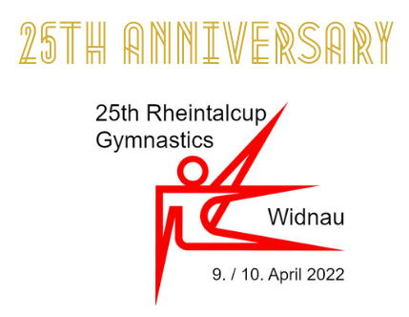
Registration
Definite INT EN

General information
Federation / Club | text
Contact Person | text
Road | text
Postcode / City | text
Phone Number | text
Email | text

An entire team | 300€ per team
Team | Name | First Name | Date of Birth
Senior | text | text | numbers
Junior | text | text | numbers
Coach | text | text | numbers
Judge | text | text | numbers

Additional Seniors, Juniors, coaches and judges | 100€ per person
Additionals | Name | First Name | Date of Birth
add | text | text | numbers
add | text | text | numbers
add | text | text | numbers
add | text | text | numbers
add | text | text | numbers

Followers | 150€ per person
Followers | Name | First Name | Date of Birth
text | text | text | numbers
text | text | text | numbers

Please send back by 5th march, 2022 to Marcel Keller | rheintalcup@tzrheintal.ch
Travel details (arrival, departure – if necessary) to
- Ralph Forster | forster.ralph@gmail.com | +41 79 316 34 19

Date | numbers Signature | text

