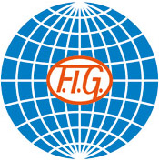
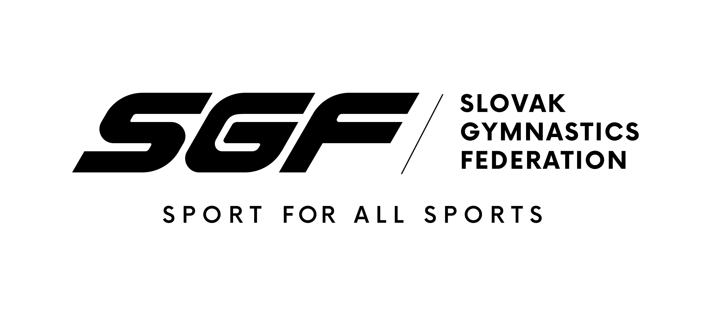

22nd Slovak Aerobic Open
Bratislava (SVK)
21st – 22nd of August 2021

DIRECTIVES

Event ID:

Dear FIG affiliated Member Federation,

The Gymnastics Federation of Slovakia has the pleasure to invite your Federation to participate in the aforementioned official FIG International Event.
Discipline | Aerobic Gymnastics
Host Federation | Slovak Gymnastics Federation  Junácka 6  832 80 Bratislava  Tel: 00421 2 49 249 149  Fax: 00421 2 49 249 538  www.sgf.sk  Contact:  Mrs. Maria Andrejkovicova  00421905662767  e-mail: andrejkovicova@sgf.sk
LOCATION | BRATISLAVA, Slovakia
DateS | From 21st – 22nd of August, 2021
Venue | Multifunctional Sports Hall, Junácka 6 , 831 80 Bratislava - Nove Mesto
APPARATUS SUPPLIER | JanssenFritsen: Aerobics Floor 2014 Ref. 1790560
RULES AND REGULATIONS | The event will be organized under the following FIG rules, as valid in the year of the event, except for any deviation mentioned in these directives:  Statutes  Code of Ethics  Technical Regulations  Code of Points and relevant Newsletters / Helpdesk  General Judges’ Rules  Specific Judges’ Rules  Anti-Doping Rules  Medical Organisation of FIG Competitions and Events  Framework for Safeguarding during Events  License Rules  Media Rules  Apparatus Norms  Rules for Sanctioning (approval) of International Events  Advertising and Publicity Rules  Regulations for Award Ceremonies  Accreditation Rules  and subsequent decisions of the FIG Executive Committee
federations invited | The Organizing Member Federation will invite all Member Federations in good standing.
AGE LIMITS AND LICENCES
  AER: ND / 8-11 years; AG1 / 12-14 years; Juniors / 15-17 years, Senior
  / 18 + years
  Juniors & Seniors - All gymnasts in good standing with the correct
  age and holding a valid FIG licence until the end of the event, may
  participate.
  The LOC will be responsible for checking the validity of all gymnasts
  Licences.
  No gymnasts will be accepted without a valid FIG Licence at the deadline
  of the Nominative Registration.
  ND & AG1 & AEROBIC DANCE & AEROBIC STEP – without FIG
  licence (no FIG licence is needed)
CATEGORIES
  IW / IM / Mixed Pair / Trio / Group (limits by categories), Aerobic Dance
  (AG1, JUN, SEN), Aerobic Step (SEN)
REGISTRATION DEADLINES
  Definitive registration: | 19th JUNE, 2021 | Must be filled in ONLINE 2 month prior to the event, http://admin.gymaerobic.com
  Nominative registration | 17th JULY, 2021 | Must be filled in ONLINE 4 weeks prior to the event, http://admin.gymaerobic.com
ENTRY FEES | The Entry fee for this event will be :  IW, IM 20,00 €  MP 30,00 €  TRIO 50,00 €  GROUP 60,00 €  AERO STEP 60,00 €  AERO DANCE 60,00 €  All the entry fees are not refundable.
  The Entry fee for this event for those national delegations who will not reserve the accommodation via the LOC will be:
  IW, IM 40,00 €
  MP 60,00 €
  TRIO 100,00 €
  GROUP 120,00 €
  AERO STEP 120,00 €
  AERO DANCE 120,00 €
  All the entry fees are not refundable.
ACCREDITATION
  The accreditation will take place at the Multifunctional Sports Hall, Junácka 6 , 831 80 Bratislava - Nove Mesto on the 20th August upon arrival. The accreditations will only be handed out to the Head of Delegation. All delegations must deliver insurance declaration, passports of all members, FIG licence of all athletes.
Event Format
  22nd Slovak Aerobic Open will have Qualifications and Finals as follows:
  Qualifications:
  The maximum number for the Qualifying rounds is four (4) per category and nation. There will be no qualification if less than 8 units in categories (IW/IM/MP/TR/GR).
  FINALS:
  National Development, Age Group 1, Juniors and Seniors:
  Each final (IW, IM, MP, TR, GR): maximum of ten (10) units: 7 best
  foreign units (max. 2 per nation) + 3 Slovak units (maximum).
  Aerobic Dance, Aerobic Step:
  ONLY the finals, no Qualifying round.
PROVISIONAL Schedule
   | Thursday, 19th August 2021
   | All Day |  |  | Arrival of the delegations | Hotels
   | Friday, 20th August 2021
   | 09:00 – 15:00 |  |  | Podium training | SPORT HALL ELAN
   | 09:00 – 12:00 |  |  | Accreditation | SPORT HALL ELAN
   | 13:00 – 13:30 |  |  | Orientation meeting | Hotel NIVY
   | 13:30 – 14:00 |  |  | Judges meeting | Hotel NIVY
   | 15:00 – 20:00 |  |  | Qualification ND all categories | Sport Hall
   |  |  |  | Finals Aerobic Step (SEN only)
   | Saturday, 21st August 2021
   | 07:30 – 10:15 |  |  | Podium training | SPORT HALL ELAN
   | 09:30 |  |  | Judges briefing | SPORT HALL ELAN
   | 10:20 |  |  | Official Opening & Presentation | SPORT HALL ELAN
   |  |  |  | of the nations (8 counts)
   | 10:30 – 18:00 |  |  | Qualifications of all categories | SPORT HALL ELAN
   |  |  |  | ND, AG1, JUN, SEN
   | Sunday,22nd August 2021
   | 08:00 – 10:00 |  |  | Podium training | SPORT HALL ELAN
   | 09:30 |  |  | Judges briefing | SPORT HALL ELAN
   | 10:20 |  |  | Presentation of the nations | SPORT HALL ELAN
   | 10:30 – 18:00 |  |  | Finals of all categories (ND, | SPORT HALL ELAN
   |  |  |  | AG1, JUN, SEN, AD)
   | 20:00 |  |  | Banquet | Hotel NIVY
   | Monday, 23rd August 2021
   | All day |  | Departure of the delegations |  | Hotels
EVENT MANAGER | Mrs. Maria Andrejkovicova  andrejkovicova@sgf.sk
MEDICAL SERVICES
  LOC will ensure the coordination of all the aspects related with medical and security areas.
VISA | Please verify immediately with your travel agent or the Slovak Embassy or Consulate in your country if a visa is required for your travel to Slovakia. The Organizing Committee will be happy to assist each Delegation member with an official invitation letter, provided that the request is made before 19th JUNE 2021 to the LOC.  The request must include the function, full name, gender, date of birth, citizenship and passport number, passport expiry date, the arrival and departure dates of the Delegation Member as well as the city the visa application support letter must be sent to.
COVID 19  FIG Guidelines | Besides the medical guidelines for the particular event, FIG also requires all the participants to follow the standard precautions.  The FIG requires all participants, judges and officials to take standard precautionary measures, such as frequent hand-washing, wearing masks or face coverings at all times and keeping a physical distance of at least 1.5 metres whenever possible.  The only situation in which the safety distance does not have to be respected is when a coach provides assistance (catch, lead, spotting) during an athlete’s performance. This phase must be kept as short as possible and the assisting person is obliged to wear a mask throughout.  Gymnasts do not need to wear a mask or face covering while they are performing at the training venue or on the FOP and keeping a physical distance of at least 1.5 metres whenever possible.  All delegation must bring Negative PCR test results 48h before the time of arrival in Slovakia.
INSURANCE | The Host Federation, the Organizing Committee and the FIG will not be responsible for any liabilities in case of accidents, illness, repatriation and the like.  The FIG Technical Regulations foresee that all participating Federations are responsible for making their own arrangements to have the necessary valid insurance coverage against illness, accidents and for repatriation for all the members of their Delegation.  The LOC will verify the insurance upon arrival of the delegation members (e.g. cover note or photocopy of the valid policy). Delegation members with insufficient insurance cover must inform the LOC in advance.
INternational TRANSPORTATION | The invited participating federations must pay for the travel costs of their delegation members (see exception herein below).  The Travel Schedule Form must be returned to the LOC by nominative registration 17th JULY 2021.
LOCAL TRANSPORTATION | LOC will provide transport from Bratislava Airport, Bratislava Railway Station and Bus Station to the hotels and back, for the national delegation booked their accommodation through the LOC.  Transport form must be returned to the Slovak Gymnastics Federation by the date of nominative registration 17th JULY 2021.  The cost of 15 € (per Delegation Member per 1 way) for the local transportation from Vienna airport to Bratislava must be paid to the Slovak Gymnastics Federation by nominative registration 17th August 2021.
ACCOMMODATION | Hotel NIVY **** (800m from the competition hall, walking distance – 10 min.)  Liscie nivy 3  821 08 Bratislava  Tel. +421 (0)2 55 41 03 90  e-mail: hotel@hotelnivy.sk  web site: www.hotelnivy.sk  The costs per room/night are as follows:  78 € (double room, including breakfast)  78 € (twin room, including breakfast)  88 € (twin room comfort, including breakfast)  97 € (triple room comfort, including breakfast)  Hotel Remy** (4,4 km from the competition hall)  Stará Vajnorská 37/A  Tel. +421 (0)2 44455063  e-mail: info@remy.sk  web site: www.hotel-remy.mozello.com  The costs per room/night are as follows:  62 € (double room, including breakfast)  73 € (double room comfort, including breakfast)  All bookings must be made through the Local Organizing Committee!  The prices charged for the hotel rooms will not exceed the usual hotel rates.  While the Accommodation Form must be returned to the LOC by definitive registration 19th JUNE 2021, the Hotel rooms will be allocated on a “first come, first serve” basis.  The invited participating federations must pay for the accommodation expenses of their delegation members.  The costs for the accommodations must be paid to the LOC as follows:  50% of the payment – 29th JUNE 2021  100% of the payment – 17th JULY 2021  Cancellation/Reimbursement Policy  Untill 19th JUNE 2021 – 50% of the payment  After 17th JULY 2021 – no reimbursement of the payment  Note for all national delegations: Please pay all payments after the invoice which will be issued from LOC – SGF only!
MEALS | During the competition, a lunch and a dinner are available at Multifunctional Sports Hall (competition venue).
JUDGES AND JURIES | Each participating federation must provide minimum one judge Cat. 1, 2, 3 or 4. All judges must have a current valid FIG brevet at the time of the event.
MUSIC | In order to simplify the management of the music and to limit the technical problems the federation are asked to submit the music in MP3 format ONLINE http://admin.gymaerobic.com  Each music file will have to contain the following information:  - The name of the nation (official abbreviation of the country);  - The first and last name of the competitor/s;  - The category (IM, IW, MP, TR, GR, AS, AD);  - The Junior or Senior  Example: SVK_ LAMOSOVA_Anita_Senior_IW1_mp3  Deadline to submit the music is 17th JUNE 2021.
BANK ACCOUNT INFORMATION | Each participating member Federation is kindly requested to integrate the ENTRY FEE, the LOCAL TRANSPORT and ACCOMMODATION payment’s purpose as follows:  Name of the bank: VUB Bratislava, pobočka POLUS  Address of the bank: Vajnorská 100, Bratislava 3, Slovakia  Number of account: 1819650954/0200  IBAN: SK23 0200 0000 0018 1965 0954  BIC: SUBASKBX  The participating federation is responsible for covering all bank fees in connection with the bank transfers.
Marketing | FIG advertising and publicity norms must be respected.
DEADLINES SUMMARY
  Definitive Registration | 19th JUNE 2021
  Nominative Registration | 17th JULY 2021
  Detailed Accommodation Form | 19th JUNE 2021
  Travel Schedule Form | 17th JULY 2021
  Visa Request Form | 19th JUNE 2021
  Music submission | 17th JULY 2021
  Payment of the Entry Fee | 19th JUNE 2021
  Payment of the Accommodation Costs 50% | 19th JUNE 2021
  Payment of the remaining 50% Accommodation Costs | 29th JUNE 2021
  Payment of the local transportation | 17th JULY 2021
ADDITIONAL INFORMATION | Detailed information for the program, schedules and organization of the event will be given to all participating federation with the Work Plan not later than 30th of JULY 2021.

Sincerely Yours,

Bratislava, 10.5.2021
Place and date: Stamp Signature of the President or
Secretary General of the FIG affiliated NF

