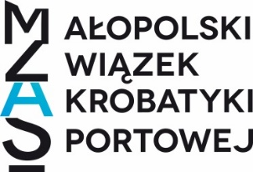
XI International tournament at Wawel
in Acrobatic Gymnastics, Trampoline, Tumbling, DMT
Form to be sent to:
Organizing Committee
Małopolski Związek Akrobatyki Sportowej w Krakowie
Contact: Starowolska Street 10, 30-231 Kraków
e-mail: marek.starczynski@mzas.pl,
Deadline: 10th Fabruary 2024

Definitive registration

Federation |  | Contact person:
 |  | Phone:
 |  | E-mail:

Category | Age category and number  Number
 | Women |  | Men
Head of Delegation
Team Manager
Judge
Coach
Competitors: | 11-16 | 12-18 | 13-19 | Senior
Women’s Pairs
Men’s Pairs
Mixed Pairs
Women’s Groups
Men’s Groups
Category | Under - 12 | Under -14 | Under - 16 | Senior
Gymnasts Tumbling women
Gymnasts Tumbling men’s
Gymnasts Trampoline women
Gymnasts Trampoline men’s
Gymnasts DMT women
Gymnasts DMT men’s
Тotal number of competition ……………………….
Number of officials ……………………….
Total number of delegation ……………………….
Place and date | Seal of the NF | NF authorised signature

Name list

No | Surname and Name | Category  (for example: TUM men, mixed pair 1) | Age Category  (for example:  under 12, 13-14) | Data of birth
1
2
3
4
5
6
7
8
9
10
11
12
13
14
15

