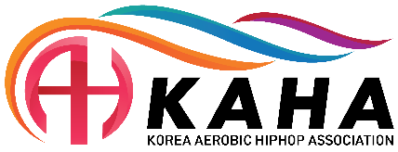
9th Korea aerobic Open “online” competition
SEOUL (KOR)
26 – 27 July, 2024

Organizing Committee / National Federation
Korea Aerobic Association
Contact person : Mr. Albert CHUNG
Tel.: + 82 2 742 8782, Fax.: + 82 2 420 2291
e-mail : kaa@aerobic.or.kr
Deadline: 17th June 2024

Nominative registration

Federation |  | Contact person:
Federation |  | Phone:
Federation |  | E-mail:
Federation |  | Adress: | Please write down the exact address to receive the certificate and diploma  -Detail:  -City:  -State:  -zip code!!:  -Tel. No

No | First Name | Last Name | Gender  M / F | Date of Birth  (dd/mm/yy) | Age Group | IM | IW | MP | TRI | GR | AD | AS | T-Shirts Size
1 |  |  |  |  |  |  |  |  |  |  |  |  | S/M/L/XL/2XL
2
3
4
5
6
7
8
9
10
11
12
13
14
15
16
17
18
19
20
21
22
23
24
25
26
27
28
- Age group : ND(National Development), AG(Age Group), JR(Junior), SEN(Senior)
 |  | First Name | Last Name | FIG-Brevet Level | E-mail(contactable) & Phone | T-Shirts Size
Judge | 1. |  |  |  |  | S/M/L/XL/2XL
 | 2.

Head of Delegation |  |  |  | S/M/L/XL/2XL
Coach |  |  |  | S/M/L/XL/2XL
Additional person | 1 |  |  | S/M/L/XL/2XL
Additional person | 2 |  |  | S/M/L/XL/2XL

Place and date | Seal of the NF | NF authorised signature
 |  | Signature of the President or Secretary General of the participating AGU affiliated NF

