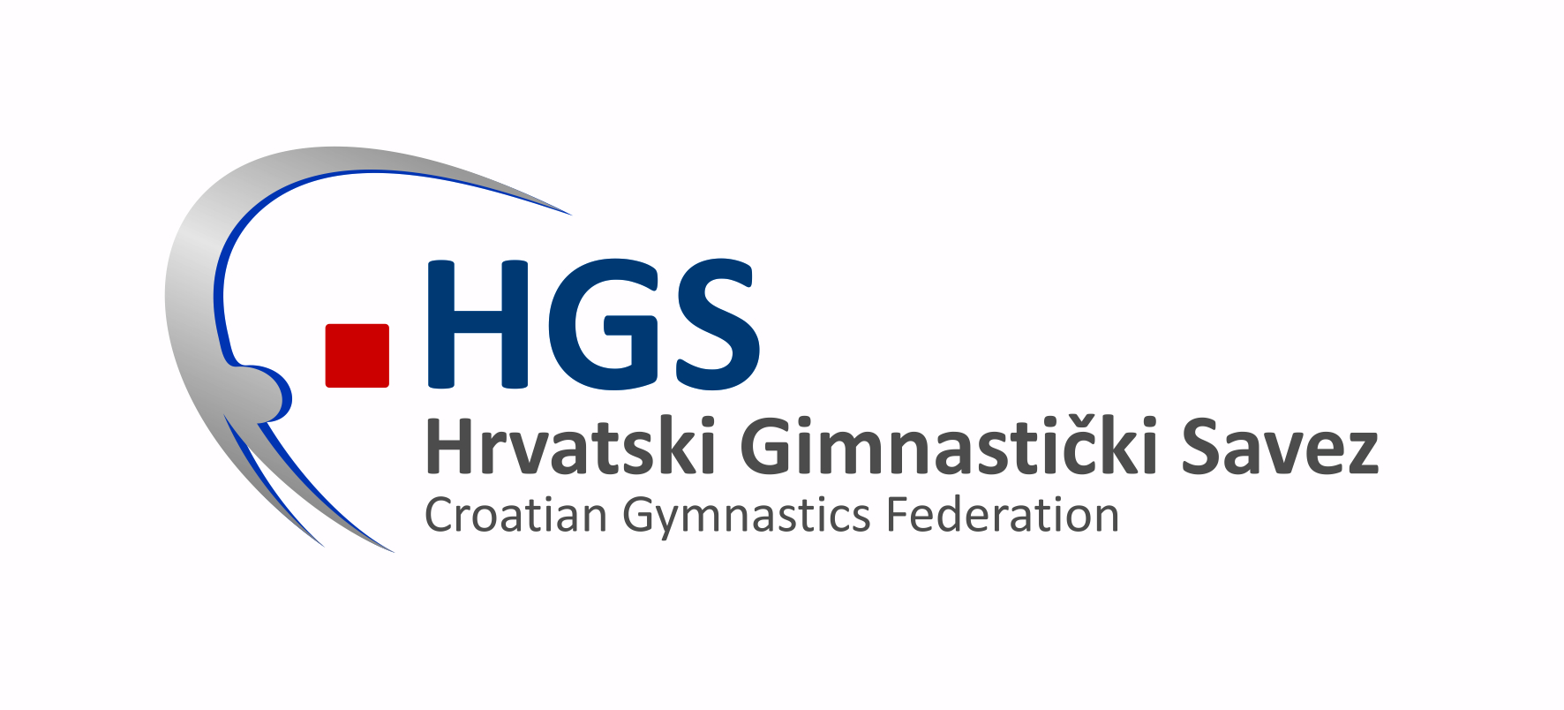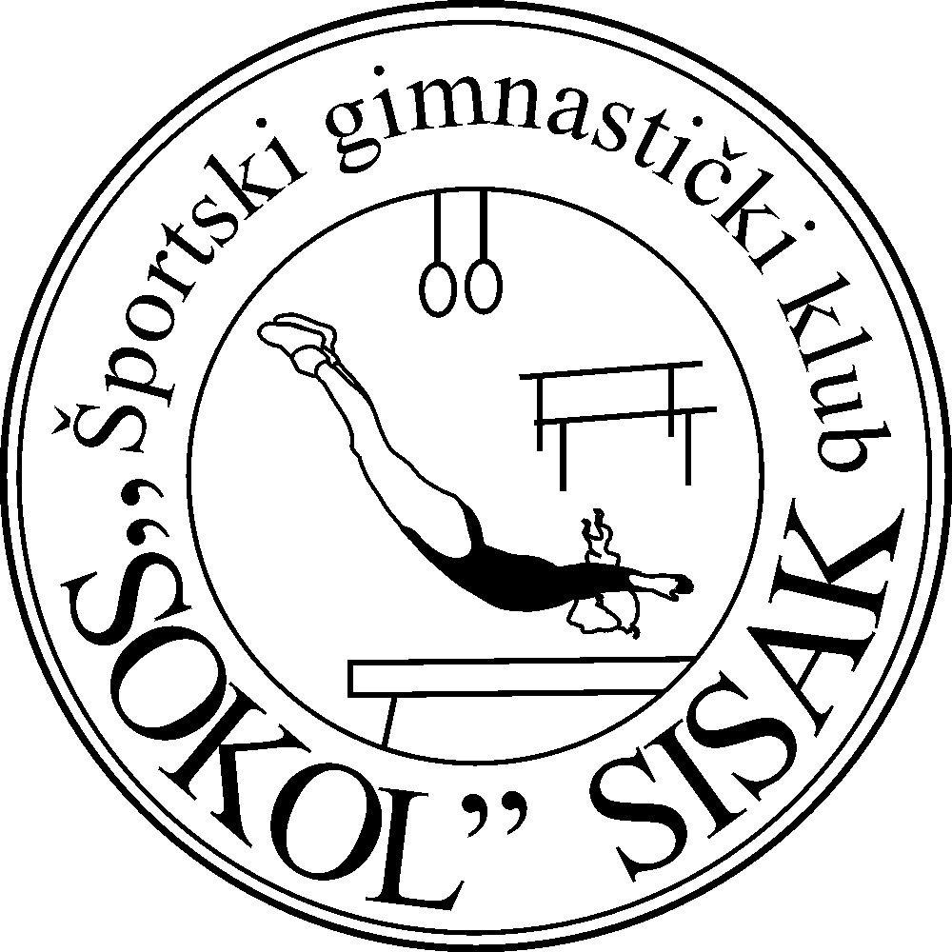

Zagreb, 167th. May 2014

INVITATION TO THE
Open Championship of Sisak
2nd International Team Competition
14th June 2014, SISAK, CROATIA

Dear gymnastics Friends,

Gymnastics Club „Sokol“, Sisak and Croatian Gymnastics Federation have the pleasure to invite your Federation to participate in Open Championship of Sisak and 2nd International team competition.

Place and Venue: Sisak, Croatia, Gym hall „Brezovica 1941“

Date: 14th June 2014.

Competition Format:

Open Championship: MAG (cadet, younger junior and junior) & WAG (younger cadet, cadet and
junior) Croatian Gymnastics Federation Program

Team competition-16 couples ( senior 1 MAG & 1 WAG)
Qualifications: 1st cycle- all 16 pairs
2nd cycle- 8 best pairs from 1st cycle
Finals: 4 best pairs from 2nd cycle qualifications

1MAG+1WAG Apparatus in 1st cycle: registered in advance
1MAG+1WAG Apparatus in 2nd cycle: registered in advance but different
from apparatus in 1st cycle
1MAG+1WAG Apparatus in 3rd cycle: registered in advance in 1st or 2nd
cycle

Registration will be accepted after payment of Entry fee and accommodation costs.
Apparatus registration on Technical meeting.

Apparatus: SPIETH

Entry fee: Open Championship 8,00 EUR per Apparatus, payment till 07th June 2014.
2nd Int. Team Competition 35,00 EUR//pair, payment till 07th June 2014.

Transport: Each delegation is responsible for its own transport.

Deadlines: Definitive Registration: 30th May 2014
Nominative Registration: 07th June 2014

Judges: Each Federation must send one MAG & one WAG Judge (min.Brevet III)

Prize Money 2nd International Team Competition
OC will pay Prize money, distributed in EUR as follows:

Ranking Pair | Prize money
1 | 500,00
2 | 300,00
3 | 200,00

Provisional Schedule: 13th June 2014: Arrival of delegations
14:00-19:00 Training
20:00 Technical meeting
14th June 2014: 09:00-16:00-Open Championship
17:30-20:00 2nd International Team Competition
15th June 2014: Departure of delegations

Bank account information: Bank name: Reiffeisen bank
Bank account: SGK Sokol, Sisak
IBAN: HR11 2484008 1102766864
SWIFT:RZBHHR2X
Payments purpose: 2nd Int. Competition

Accommodation: -20,00 EUR (only bed, facility 400 m from gym hall)
-20,00 EUE hotel Alen plus*** (only bed, meals 5,5 EUR each)
-32,00 EUR hotel Panonija*** double pro person/night/breakfast
-35,00 EUR hotel Panonija*** double pro person/night/breakfast+dinner
-39,00 EUR hotel Panonija*** double pro person/night/full board
(on request you can book rooms with 3 or 4 beds)
-booking for facility- e-mail:georgibg@net.hr, cell:+385 91 1740302
-booking for hotelAlen- phone:+385 44 534527, fax:+385 44 534528, cell:+385 98 1664021
-booking for hotel Panonija-e-mail:recepcija@hotel-panonija.hr

RULES OPEN CHAMPIONSHIP MAG:

Category | Age | Year of birth | Number of elements | Element weight | Special reqirements | Weight for  jump | Vault | Bonus
 |  |  |  |  |  |  |  | Floor | High Bar
CADETS | 12 years and younger | 2002. and younger | 6 | FIG  A=0,1  B=0,2  C=0,3  D=0,4  E=0,5  F=0,6  G=0,7 | FIG  Each 0,5 | A=0,2  B=0,4  C=0,5 | 115 cm  1 ili 2  board  FIG | A+C=0,1  B+B=0,1  A+D=0,2  B+C=0,2  C+C=0,2 | LET+pritka  C+B=0,1  C+C=0,2  LET+LET  C+C=0,2
YOUNGER JUNIORS | 15 years and younger | 1999.  and younger | 8 | FIG  A=0,1  B=0,2  C=0,3  D=0,4  E=0,5  F=0,6  G=0,7 | FIG  Each 0,5 | A=0,0  B=0,3  C=0,5 | 125 cm  FIG | A+C=0,1  B+B=0,1  A+D=0,2  B+C=0,2  C+C=0,2 | LET+pritka  C+B=0,1  C+C=0,2  LET+LET  C+C=0,2
JUNIORS | 15-18 years | 1996. – 1999. | 8 | FIG  A=0,1  B=0,2  C=0,3  D=0,4  E=0,5  F=0,6  G=0,7 | FIG  Each 0,5 | FIG | 135 cm  FIG | FIG | FIG

RULES OPEN CHAMPIONSHIP WAG:

Category | Age | Year of birth | Number of elements | Element weight | Special reqirements | Weight for  jump | Vault | Bonus
YOUNGER  CADETS | 11 years and younger | 2003. and younger | 6 | FIG  A=0,1  B=0,2 | Max. 3 KZ one is jump | A=0,2  B= 0,5 | 110 ili 125 cm  2 different jumps, average 2 boards | FIG
CADETS | 13. years and younger | 2001. and younger | 8 | C= 0,3  D= 0,4  E= 0,5 | Max. 4 KZ  one is jump | A= 0,1  B=0,3  C= 0,5 | 120 ili 125 cm  2 same or different jumps, average | FIG
JUNIORS | 15 years and younger | 1999. and younger | 8 | F= 0,6  G= 0,7  H= 0.,8 | FIG  each KZ 0,5 | FIG=  0,5 | 125 cm  2 different jumps, possible from the same group | FIG

We are looking forward to welcoming your delegation in Sisak.

Sincerely Yours,

PRESIDENT OF CGF:
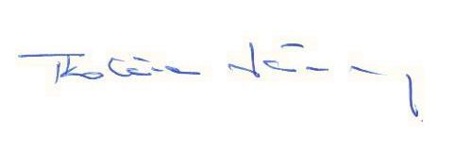
mr.sc. Stevo Tkalčec

COMPETITION DIRECTOR:
Georgy Kazakov

