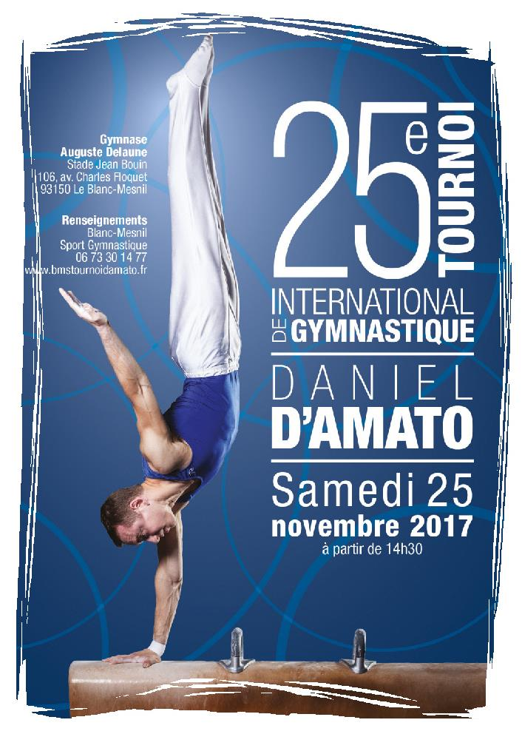
25ème TOURNOI INTERNATIONAL DE GYMNASTIQUE « DANIEL D’AMATO » LE BLANC-MESNIL
25 novembre 2017

Concours Général Individuel Masculin

CLT | Nom Prénom | Ann. Nais. | Nation | Total | Sol | Arçons | Anneaux | Saut 1 | Saut 2 | Parallèles | Fixe
1 | MASIA PACHOLCZYK Tom | 2000 | INSEP | 73,604 | 13,533 | 10,734 | 13,034 | 12,570 | 0,000 | 12,100 | 11,633
2 | DESANGES Lucas | 2002 | INSEP | 73,144 | 12,567 | 10,100 | 12,767 | 13,370 | 0,000 | 11,340 | 13,000
3 | BLIN Alexis | 2001 | CRIF | 72,233 | 12,733 | 10,967 | 11,300 | 12,400 | 0,000 | 12,600 | 12,233
4 | VASHCHENKO Roman | 2000 | UKRAINE | 71,777 | 12,200 | 11,434 | 12,667 | 12,470 | 0,000 | 12,940 | 10,066
5 | STELMAKH Radomyr | 2005 | UKRAINE | 69,269 | 11,133 | 11,600 | 12,500 | 11,400 | 0,000 | 12,070 | 10,566
6 | PRETE Flavien | 2000 | CRIF | 69,140 | 11,233 | 11,300 | 11,234 | 12,970 | 0,000 | 11,170 | 11,233
7 | NOBLET Lucas | 2000 | CRIF | 68,203 | 12,000 | 11,267 | 10,967 | 11,940 | 0,000 | 11,840 | 10,189
8 | LIXON Thiméo | 2004 | OAJLP | 67,903 | 11,733 | 10,600 | 11,434 | 11,670 | 0,000 | 11,800 | 10,666
9 | KOLODII Pantely | 2001 | UKRAINE | 65,940 | 7,133 | 10,634 | 12,467 | 12,300 | 0,000 | 12,840 | 10,566
10 | CARMONA Hugo | 2004 | OAJLP | 65,140 | 11,800 | 9,767 | 11,467 | 10,070 | 0,000 | 11,370 | 10,666
11 | JOINEL Axel | 2003 | BOULAZAC | 64,610 | 12,033 | 11,700 | 7,034 | 10,940 | 0,000 | 12,170 | 10,733
12 | PLATRIER Maël | 2003 | BOULAZAC | 63,574 | 11,867 | 7,767 | 11,234 | 11,300 | 0,000 | 10,540 | 10,866
13 | DUESO Tom | 2003 | BOULAZAC | 63,104 | 8,633 | 8,134 | 11,767 | 12,500 | 0,000 | 12,370 | 9,700
14 | INGALL Louis | 2005 | OAJLP | 61,371 | 11,367 | 7,567 | 10,734 | 11,270 | 0,000 | 10,700 | 9,733
15 | RETOUR Romain | 1999 | BLANC MESNIL | 59,947 | 10,700 | 10,467 | 10,767 | 11,040 | 0,000 | 9,640 | 7,333
16 | HODEAU Romuald | 1995 | BLANC MESNIL | 34,168 | 0,000 | 6,434 | 9,134 | 0,000 | 0,000 | 9,300 | 9,300
17 | TRAORE MALATRE Leeroy | 2007 | BLANC MESNIL | 28,400 | 10,433 | 3,067 | 5,800 | 0,000 | 0,000 | 9,100 | 0,000

